Version Control with Git
Table des matières

1 Introduction 1
3 Getting Started 2
Viewing your commits 2
Viewing Commit differences 2
Removing and Renaming Files in your repository 2
Configuration Files 2
Configuring an Alias 3
4 Basic Git Concepts 3
Git Object Types 3
Inside the .git directory 4
Files and Trees 5
Tags 5
5 File management and the index 5
CHAPTER 6 Commits 8
CHAPTER 7 Branches 11
CHAPTER 8 Diffs 13
CHAPTER 13 Repository Management 16
Repository Clones 17
CHAPTER 17 Submodule Best Practices 25
CHAPTER 18 Using Git with Subversion Repositories 26
CHAPTER 19 Advanced Manipulations 26
CHAPTER 20 Tips, Tricks, and Techniques 28
21 Git and Github 31

1 Introduction

A tool that manages and tracks different versions of software or other content is referred to generically as a version control system (VCS), a source code manager (SCM), a revision control system (RCS).

3 Getting Started

Git commands understand both “short” and “long” options. For example, the git commit command treats the following examples as equivalents

$ git commit -m "Fixed a typo."
$ git commit --message="Fixed a typo."

The short form, -m, uses a single hyphen, whereas the long form, --message, uses two.(This is consistent with the GNU long options extension.) Some options exist only in one form.

Finally, you can separate options from a list of arguments via the “bare double dash” convention. For instance, use the double dash to contrast the control portion of the command line from a list of operands, such as filenames.
$ git diff -w master origin -- tools/Makefile

You may need to use the double dash to separate and explicitly identify filenames if they might otherwise be mistaken for another part of the command. For example, if you happened to have both a file and a tag named main.c, then you will get different behavior:
# Checkout the tag named "main.c"
$ git checkout main.c
# Checkout the file named "main.c"
$ git checkout -- main.c

Git places all its revision information in this one, top-level .git directory.

Viewing your commits
Once you have one or more commits in the repository, you can inspect them in a variety of ways.
$ git log

To see more detail about a particular commit, use git show with a commit number
$ git show 9da581d910c9c4ac93557ca4859e767f5caf5169

If you run git show without an explicit commit number, it simply shows the details of the most recent commit.

Viewing Commit differences
To see the differences between the two revisions of index.html, recall both full commit ID names and run git diff:

$ git diff 9da581d910c9c4ac93557ca4859e767f5caf5169 \
ec232cddfb94e0dfd5b5855af8ded7f5eb5c90d6

Removing and Renaming Files in your repository

Removing a file from a repository is analogous to adding a file but uses git rm.

Configuration Files

Git’s configuration files are all simple text files in the style of .ini files. They record various choices and settings used by many Git commands. Some settings represent purely personal preferences (should a color.pager be used?); others are vital to a repository functioning correctly (core.repositoryformatversion); and still others tweak command behavior a bit (gc.auto).

Like many tools, Git supports a hierarchy of configuration files. In decreasing precedence they are:

git/config
- Repository-specific configuration settings manipulated with the --file option or by default. These settings have the highest precedence.
~/.gitconfig
- User-specific configuration settings manipulated with the --global option.
/etc/gitconfig
- System-wide configuration settings manipulated with the --system option if you have proper Unix file write permissions on it. These settings have the lowest precedence. Depending on your actual installation, the system settings file might be somewhere else (perhaps in /usr/local/etc/gitconfig), or may be entirely absent.

Or, to set a repository-specific name and email address that would override a
--global setting, simply omit the --global flag:
$ git config user.name "Jon Loeliger"
$ git config user.email "jdl@special-project.example.org"

Use git config -l to list the settings of all the variables collectively found in the complete set of configuration files:
$ git config –l

Because the configuration files are simple text files, you can view their contents with cat and edit them with your favorite text editor, too.
$ cat .git/config

Use the --unset option to remove a setting:
$ git config --unset --global user.email

Configuring an Alias

For starters, here is a tip for setting up command aliases. If there is a common but
complex Git command that you type frequently, consider setting up a simple Git alias
for it.
$ git config --global alias.show-graph 'log --graph --abbrev-commit --pretty=oneline'

4 Basic Git Concepts
A Git repository is simply a database containing all the information needed to retain and manage the revisions and history of a project

Within a repository, Git maintains two primary data structures, the object store and the index. All of this repository data is stored at the root of your working directory in a hidden subdirectory named .git.

The object store is designed to be efficiently copied during a clone operation as part of the mechanism that supports a fully distributed VCS. The index is transitory information, is private to a repository, and can be created or modified on demand as needed.

Git Object Types
At the heart of Git’s repository implementation is the object store. It contains your original data files and all the log messages, author information, dates, and other information required to rebuild any version or branch of the project. Git places only four types of objects in the object store: the blobs, trees, commits, and tags. These four atomic objects form the foundation of Git’s higher level data structures.

Blobs
- Each version of a file is represented as a blob. Blob, a contraction of “binary large object,” is a term that’s commonly used in computing to refer to some variable or file that can contain any data and whose internal structure is ignored by the program. A blob is treated as being opaque. A blob holds a file’s data but does not contain any metadata about the file or even its name.

Trees
- A tree object represents one level of directory information. It records blob identifiers, path names, and a bit of metadata for all the files in one directory. It can also recursively reference other (sub)tree objects and thus build a complete hierarchy of files and subdirectories.

Commits
- A commit object holds metadata for each change introduced into the repository, including the author, committer, commit date, and log message. Each commit points to a tree object that captures, in one complete snapshot, the state of the repository at the time the commit was performed. The initial commit, or root commit, has no parent. Most commits have one commit parent, although later in the book (Chapter 9) we explain how a commit can reference more than one parent.
Tags
- A tag object assigns an arbitrary yet presumably human readable name to a specific object, usually a commit. Although 9da581d910c9c4ac93557ca4859e767f5caf5169 refers to an exact and well-defined commit, a more familiar tag name like Ver-1.0-Alpha might make more sense!

Over time, all the information in the object store changes and grows, tracking and modeling your project edits, additions, and deletions. To use disk space and network bandwidth efficiently, Git compresses and stores the objects in pack files, which are also placed in the object store.

The Git object store is organized and implemented as a content-addressable storage system. Specifically, each object in the object store has a unique name produced by applying SHA1 to the contents of the object, yielding an SHA1 hash value

Inside the .git directory

To begin, initialize an empty repository using git init and then run find to reveal what’s created.

$ mkdir /tmp/hello
$ cd /tmp/hello
$ git init
Initialized empty Git repository in /tmp/hello/.git/
# List all the files in the current directory
$ find .

As you can see, .git contains a lot of stuff.

Initially, the .git/objects directory (the directory for all of Git’s objects) is empty, except
for a few placeholders.
$ find .git/objects

Let’s now carefully create a simple object:
$ echo "hello world" > hello.txt
$ git add hello.txt
If you typed “hello world” exactly as it appears here (with no changes to spacing or
capitalization), then your objects directory should now look like this:
$ find .git/objects

The hash in this case is 3b18e512dba79e4c8300dd08aeb37f8e728b8dad. The 160 bits of an SHA1 hash correspond to 20 bytes, which takes 40 bytes of hexadecimal to display, so the content is stored as .git/objects/3b/18e512dba79e4c8300dd08aeb37f8e728b8dad. Git inserts a / after the first two digits to improve filesystem efficiency.

To show that Git really hasn’t done very much with the content in the file (it’s still the same comforting “hello world”), you can use the hash to pull it back out of the object store any time you want:

$ git cat-file -p 3b18e512dba79e4c8300dd08aeb37f8e728b8dad
hello world

Files and Trees

The index is found in .git/index and keeps track of file pathnames and corresponding blobs. Each time you run commands such as git add, git rm, or git mv, Git updates the index with the new pathname and blob information

Whenever you want, you can create a tree object from your current index by capturing
a snapshot of its current information with the low-level git write-tree command.
At the moment, the index contains exactly one file, hello.txt.
$ git ls-files -s
100644 3b18e512dba79e4c8300dd08aeb37f8e728b8dad 0 hello.txt

Here you can see the association of the file, hello.txt, and the 3b18e5... blob.
Next, let’s capture the index state and save it to a tree object:
$ git write-tree
68aba62e560c0ebc3396e8ae9335232cd93a3f60

$ find .git/objects
.git/objects
.git/objects/68

But what does a tree look like? Because it’s an object, just like the blob, you can use
the same low-level command to view it.
$ git cat-file -p 68aba6

It is now easy to see that the tree object has captured the information that was in the
index when you ran git ls-files -s.

Tags
Finally, the last object Git manages is the tag. Although Git implements only one kind
of tag object, there are two basic tag types, usually called lightweight and annotated.

You create an annotated, unsigned tag with a message on a commit using the git tag
command:
$ git tag -m "Tag version 1.0" V1.0 3ede462
You can see the tag object via the git cat-file -p command

Git usually tags a commit object, which points to a tree object, which encompasses the
total state of the entire hierarchy of files and directories within your repository

5 File management and the index

When you manage your code with Git, you edit in your working directory, accumulate changes in your index, and commit whatever has amassed in the index as a single changeset.

You can query the state of the index at any time with the command git status. It explicitly calls out what files Git considers staged. You can also peer into the internal state of Git with “plumbing” commands such as git ls-files.

You’ll also likely find the git diff command useful during staging. (Diffs are discussed extensively in Chapter 8.) This command can display two different sets of changes: git diff displays the changes that remain in your working directory and are not staged;
git diff --cached shows changes that are staged and will therefore contribute to your next commit

You can use both variations of git diff to guide you through the process of staging changes. Initially, git diff is a large set of all modifications, and --cached is empty. As you stage, the former set will shrink and the latter set will grow. If all your working changes are staged and ready for a commit, the --cached will be full and git diff will show nothing.

Editors and build environments often leave temporary or transient files among your source code. Such files usually shouldn’t be tracked as source files in a repository. To have Git ignore a file within a directory, simply add that file’s name to the special file .gitignore

You can use git ls-files to peer under the object model hood and find the SHA1 values for those staged files:
$ git ls-files –stage

Using git commit --all
The -a or --all option to git commit causes it to automatically stage all unstaged, tracked file changes—including removals of tracked files from the working copy— before it performs the commit.

Writing Commit Log Messages
If you are in the editor writing a commit log message and for some reason decide to abort the operation, simply exit the editor without saving; this results in an empty log message. If it’s too late for that because you’ve already saved, just delete the entire log message and save again. Git will not process an empty (no text) commit.

Using git rm
Git will remove a file only from the index or from the index and working directory simultaneously. Git will not remove a file just from the working directory; the regular rm command may be used for that purpose

Because git rm is also an operation on the index, the command won’t work on a file
that hasn’t been previously added to the repository or index; Git must first be aware of
a file

To convert a file from staged to unstaged, use git rm --cached:

Whereas git rm --cached removes the file from the index and leaves it in the working directory, git rm removes the file from both the index and the working directory

Before Git removes a file, it checks to make sure the version of the file in the working
directory matches the latest version in the current branch (the version that Git commands
call the HEAD). This verification precludes the accidental loss of any changes (due
to your editing) that may have been made to the file.

Use git rm -f to force the removal of your file. Force is an explicit mandate and removes the file even if you have altered it since your last commit.

Darn! Git removed the working copy, too! But don’t worry. VCSs are good at recovering
old versions of files:
$ git checkout HEAD – data

Using git mv

the following sequences of commands are equivalent Git operations:
$ mv stuff newstuff
$ git rm stuff
$ git add newstuff
and
$ git mv stuff newstuff

If you happen to check the history of the file, you may be a bit disturbed to see that Git has apparently lost the history of the original data file and remembers only that it renamed data to the current name:
$ git log mydata

Git does still remember the whole history, but the display is limited to the particular filename you specified in the command. The --follow option asks Git to trace back through the log and find the whole history associated with the content:
$ git log --follow mydata

One of the classic problems with VCSs is that renaming a file can cause them to lose track of a file’s history. Git preserves this information even after a rename.

Git, on the other hand, doesn’t keep track of a rename. You can move or copy hello.txt anywhere you want, but doing so affects only tree objects. (Remember that tree objects store the relationships between content, whereas the content itself is stored in blobs.) A look at the differences between two trees makes it obvious that the blob named 3b18e5... has moved to a new place

The .gitignore File
But Git also supports a much richer mechanism. A .gitignore file can contain a list of
filename patterns that specify what files to ignore. The format of .gitignore is as follows

• Blank lines are ignored, and lines starting with a pound sign (#) can be used for comments. However, the # does not represent a comment if it follows other text on the line.

• A simple, literal filename matches a file in any directory with that name.

• A directory name is marked by a trailing slash character (/). This matches the named directory and any subdirectory but does not match a file or a symbolic link.

• A pattern containing shell globbing characters, such as an asterisk (*), is expanded as a shell glob pattern. Just as in standard shell globbing, the match cannot extend across directories and so an asterisk can match only a single file or directory name. But an asterisk can still be part of a pattern that includes slashes to specify directory names (e.g., debug/32bit/*.o).

• An initial exclamation point (!) inverts the sense of the pattern on the rest of the line. Additionally, any file excluded by an earlier pattern but matching an inversion rule is included. An inverted pattern overrides lower precedence rules.

Furthermore, Git allows you to have a .gitignore file in any directory within your repository. Each file affects its directory and all subdirectories. The .gitignore rules also cascade: you can override the rules in a higher directory by including an inverted pattern (using the initial !) in one of the subdirectories.

To resolve a hierarchy with multiple .gitignore directories, and to allow command-line addenda to the list of ignored files, Git honors the following precedence, from highest to lowest:
• Patterns specified on the command line.
• Patterns read from .gitignore in the same directory.
• Patterns in parent directories, proceeding upward. Hence, the current directory’s patterns overrule the parents’ patterns, and the parents close to the current directory take precedence over higher parents.
• Patterns from the .git/info/exclude file.
• Patterns from the file specified by the configuration variable core.excludefile.

Because a .gitignore is treated as a regular file within your repository, it is copied during clone operations and applies to all copies of your repository. In general, you should place entries into your version controlled .gitignore files only if the patterns apply to all derived repositories universally.

If the exclusion pattern is somehow specific to your one repository and should not (or might not) be applicable to anyone else’s clone of your repository, then the patterns should instead go into the .git/info/exclude file, because it is not propagated during clone operations. Its pattern format and treatment is the same as .gitignore files.

Here’s another scenario. It’s typical to exclude .o files, which are generated from source by the compiler. To ignore .o files, place *.o in your top level .gitignore. But what if you also had a particular *.o file that was, say, supplied by someone else and for which you couldn’t generate a replacement yourself? You’d likely want to explicitly track that particular file. You might then have a configuration like this:

CHAPTER 6 Commits

refs and symrefs
A ref is an SHA1 hash ID that refers to an object within the Git object store. Although a ref may refer to any Git object, it usually refers to a commit object. A symbolic reference, or symref, is a name that indirectly points to a Git object. It is still just a ref.

Local topic branch names, remote tracking branch names, and tag names are all refs.

Each symbolic ref has an explicit, full name that begins with refs/ and each is stored hierarchically within the repository in the .git/refs/ directory. There are basically three different namespaces represented in refs/: refs/heads/ref for your local branches, refs/remotes/ref for your remote tracking branches, and refs/tags/ref for your tags.

You can use either a full ref name or its abbreviation, but if you have a branch and a tag with the same name, Git applies a disambiguation heuristic and uses the first match according to this list from the git rev-parse manpage:
.git/ref
.git/refs/ref
.git/refs/tags/ref
.git/refs/heads/ref
.git/refs/remotes/ref
.git/refs/remotes/ref/HEAD

For example, a local topic branch named dev is really a short form of refs/heads/dev. Remote tracking branches are in the refs/remotes/ namespace, so origin/master really names refs/remotes/origin/master. And finally, a tag such as v2.6.23 is short for refs/tags/v2.6.23.

The first rule is usually just for a few refs described later: HEAD, ORIG_HEAD, FETCH_HEAD,
CHERRY_PICK_HEAD, and MERGE_HEAD.

Git maintains several special symrefs automatically for particular purposes. They can be used anywhere a commit is used.

HEAD:
HEAD always refers to the most recent commit on the current branch. When you change branches, HEAD is updated to refer to the new branch’s latest commit.

ORIG_HEAD
Certain operations, such as merge and reset, record the previous version of HEAD in
ORIG_HEAD just prior to adjusting it to a new value. You can use ORIG_HEAD to recover
or revert to the previous state or to make a comparison.

FETCH_HEAD
When remote repositories are used, git fetch records the heads of all branches
fetched in the file .git/FETCH_HEAD. FETCH_HEAD is a shorthand for the head of
the last branch fetched and is valid only immediately after a fetch operation. Using
this symref, you can find the HEAD of commits from git fetch even if an anonymous
fetch that doesn’t specifically name a branch is used. The fetch operation is covered
in Chapter 12.

MERGE_HEAD
When a merge is in progress, the tip of the other branch is temporarily recorded in
the symref MERGE_HEAD. In other words, MERGE_HEAD is the commit that is being
merged into HEAD.

All of these symbolic references are managed by the plumbing command git symbolic-ref.

Relative Commit Names
Git also provides mechanisms for identifying a commit relative to another reference,
commonly the tip of a branch.

Within a single generation, the caret is used to select a different parent. Given a commit
C, C^1 is the first parent, C^2 is the second parent, C^3 is the third parent, and so on, as
shown in Figure 6-1.

The tilde is used to go back before an ancestral parent and select a preceding generation. Again, given the commit C, C~1 is the first parent, C~2 is the first grandparent, and C~3
is the first great-grandparent. When there are multiple parents in a generation, the first
parent of the first parent is followed. You might also notice that both C^1 and C~1 refer
to the first parent; either name is correct, and is shown in Figure 6-2.

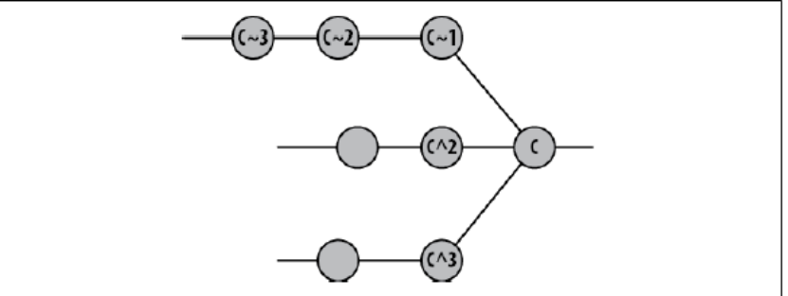

Commit History
Viewing Old Commits

One technique to constrain history is to specify a commit range using the form since..until. Given a range, git log shows all commits following since running through until. Here’s an example.
$ git log --pretty=short --abbrev-commit master~12..master~10

Use the -p option to print the patch, or changes, introduced by the commit.
$ git log -1 -p 4fe86488

The --stat option enumerates the files changed in a commit and tallies how many lines were modified in each file.

$ git log --pretty=short --stat master~12..master~10

Compare the output of git log --stat with the output of git diff --stat. There is a fundamental difference in their displays. The former produces a summary for each individual commit named in the range, whereas the latter prints a single summary of the total difference between two repository states named on the command line.

Another command to display objects from the object store is git show. You can use it to see a commit:
$ git show HEAD~2
or to see a specific blob object:
$ git show origin/master:Makefile
In the latter display, the blob shown is the Makefile from the branch named origin/master.

Commit Ranges
Many Git commands allow you to specify a commit range. In its simplest instantiation,
a commit range is a shorthand for a series of commits. More complex forms allow you
to include and exclude commits.
A range is denoted with a double-period (..), as in start..end, where start and end

The example used the range master~12..master~10 to specify the 11th and 10th prior commits on the master branch

The range M~12..M~10 represents two commits, the 11th and 10th oldest commits, which are labeled A and B. The range does not include M~12. Why? It’s a matter of definition. A commit range, start..end, is defined as the set of commits reachable from end that are not reachable from start. In other words, “the commit end is included” whereas “the commit start is excluded.” Usually this is simplified to just the phrase “in end but not start.”

When you specify a commit Y, to git log, you are actually requesting Git to show the log for all commits that are reachable from Y. You can exclude a specific commit X and all commits reachable from X with the expression ^X.

Combining the two forms, git log ^X Y is the same as git log X..Y and might be paraphrased as “give me all commits that are reachable from Y and don’t give me any commit leading up to and including X.”

The commit range X..Y is mathematically equivalent to ^X Y. You can also think of it as a set subtraction: Use everything leading up to Y minus everything leading up to and including X.

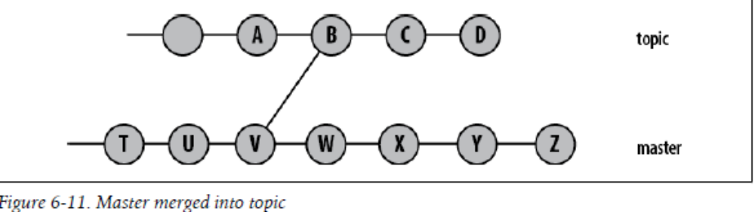

The range topic..master represents W, X, Y, and Z.

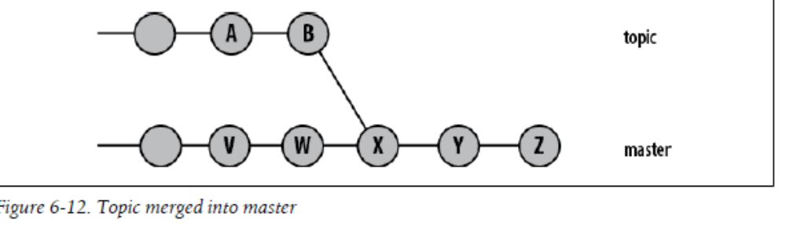
the range topic..master represents V, W, X, Y, and Z.

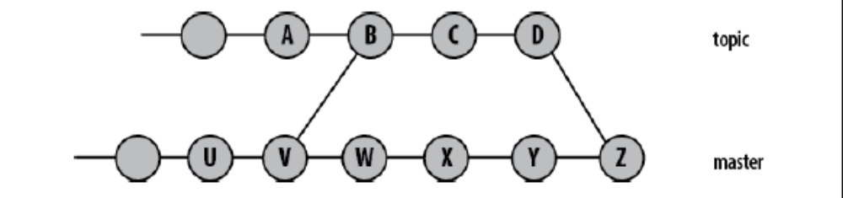

In this case, topic..master, contains only the commits W, X, Y, and Z

There are two other range permutations. If you leave either the start or end commits out of range, HEAD is assumed. Thus, ..end is equivalent to HEAD..end and start.. is equivalent to start..HEAD.

Finally, just as start..end can be thought of as representing a set subtraction operation, the notation A...B (using three periods) represents the symmetric difference between A and B, or the set of commits that are reachable from either A or B but not from both. Because of the function’s symmetry, neither commit can really be considered a start or end. In this sense A and B are equal.

More formally, the set of revisions in the symmetric difference between A and B,
A...B, is given by
$ git rev-list A B --not $(git merge-base --all A B)

Using git blame
Another tool you can use to help identify a particular commit is git blame. This command
tells you who last modified each line of a file and which commit made the change.
$ git blame -L 35, init/version.c

Using Pickaxe

Wheareas git blame tells you about the current state of a file, git log -Sstring searches back through the history of a file’s diffs for the given string. By searching the actual diffs between revisions, this command can find commits that perform a change in both additions and deletions.

$ git log -Sinclude --pretty=oneline --abbrev-commit init/version.c

Each of the commits listed on the left (cd354f1, etc.) will either add or delete lines that contain the word include. Be careful, though. If a commit both adds and subtracts exactly the same number of instances of lines with your key phrase, that won’t be shown. The commit must have a change in the number of additions and deletions in order to count. The -S option to git log is called pickaxe. That’s brute force archeology for you.

CHAPTER 7 Branches

A branch is the fundamental means of launching a separate line of development within a software project.

Because the original commit from which a branch was started is not explicitly identified,
that commit (or its equivalent) can be found algorithmically using the name of the
original branch from which the new branch forked:

$ git merge-base original-branch new-branch

For instance, to make a bug fix on the Version 2.3 release of your software, you might specify a branch named rel-2.3 as the starting commit:
$ git branch prs/pr-1138 rel-2.3

The git branch command lists branch names found in the repository.
$ git branch
Checking out Branches
As mentioned earlier in this chapter, your working directory can reflect only one branch at a time. To start working on a different branch, issue the git checkout command. Given a branch name, git checkout makes the branch the new, current working branch. It changes your working tree file and directory structure to match the state of the given branch.

$ git checkout bug/pr-1
The files and directory structure of your working tree have been updated to reflect the state and contents of the new branch, bug/pr-1.

Checking out When You Have Uncommitted Changes
Git precludes the accidental removal or modification of data in your local working tree
without your explicit request. Files and directories in your working directory that are
not being tracked are always left alone; Git won’t remove or modify them. However,
if you have local modifications to a file that are different from changes that are present
on the new branch, Git issues an error message such as the following and refuses to
check out the target branch:

If you really don’t care about losing changes in your working directory
and are willing to throw them away, you can force Git to perform the
checkout by using the -f option.

Merging Changes into a Different Branch
In the previous section, the current state of your working directory conflicted with that
of the branch you wanted to switch to. What’s needed is a merge: The changes in your
working directory must be merged with the files being checked out.
If possible or if specifically requested with the -m option, Git attempts to carry your
local change into the new working directory by performing a merge operation between
your local modifications and the target branch.

$ git checkout -m dev

Unless some problem prevents a checkout command from completing, the command:

$ git checkout -b new-branch start-point

is exactly the same as the two-command sequence:
$ git branch new-branch start-point
$ git checkout new-branch

Detached HEAD Branches
However, you can check out any commit. In such an instance, Git creates a sort of
anonymous branch for you called a detached HEAD.

Deleting Branches

The command git branch -d branch removes the named branch from a repository. Git prevents you from removing the current branch:
$ git branch -d bug/pr-3

But there is another subtle issue. Git won’t allow you to delete a branch that contains commits that are not also present on the current branch. That is, Git prevents you from accidentally removing development in commits that will be lost if the branch were to be deleted.

Finally, as the error message suggests, you can override Git’s safety check by using –D instead of -d. Do this if you are certain you don’t want the extra content in that branch

Otherwise, without a reference to them, commits and blobs are unreachable and will eventually be collected as garbage by the git gc tool.

After accidentally removing a branch or other ref, you can recover it by using the git reflog command. Other commands such as git fsck and configuration options such as gc.reflogExpire and gc.pruneExpire can
also help recover lost commits, files, and branch heads.

CHAPTER 8 Diffs

A diff is a compact summary of the differences (hence the name “diff”) between two items

Git has its own diff facility and can likewise produce a digest of differences. The command
git diff can compare files much akin to Unix’s diff command. Moreover, like diff -r, Git can traverse two tree objects and generate a representation of the variances. But git diff also has its own nuances and powerful features tailored to the particular needs of Git users

Forms of the git diff Command

There are three basic sources for tree or treelike objects to use with git diff:
• Any tree object anywhere within the entire commit graph
• Your working directory
• The index

Typically, the trees compared in a git diff command are named via commits, branch names, or tags

The git diff command can perform four fundamental comparisons using various combinations of those three sources.

- git diff
git diff shows the difference between your working directory and the index. It exposes what is dirty in your working directory and is thus a candidate to stage for your next commit. This command does not reveal differences between what’s in your index and what’s permanently stored in the repository (not to mention remote repositories you might be working with).

- git diff commit
This form summarizes the differences between your working directory and the given commit. Common variants of this command name HEAD or a particular branch name as the commit.

- git diff - -cached commit
This command shows the differences between the staged changes in the index and the given commit. A common commit for the comparison—and the default if no commit is specified—is HEAD. With HEAD, this command shows you how your next commit will alter the current branch. If the option --cached doesn’t make sense to you, perhaps the synonym –staged will. It is available in Git version 1.6.1 and later.

- git diff commit1 commit2
If you specify two arbitrary commits, the command displays the differences between the two. This command ignores the index and working directory, and it is the workhorse for arbitrary comparisons between two trees that are already in your object store.

The number of parameters on the command line determines what fundamental form is used and what is compared.
If you don’t supply a tree object or two, then git diff compares implied sources, such as your index or working directory.

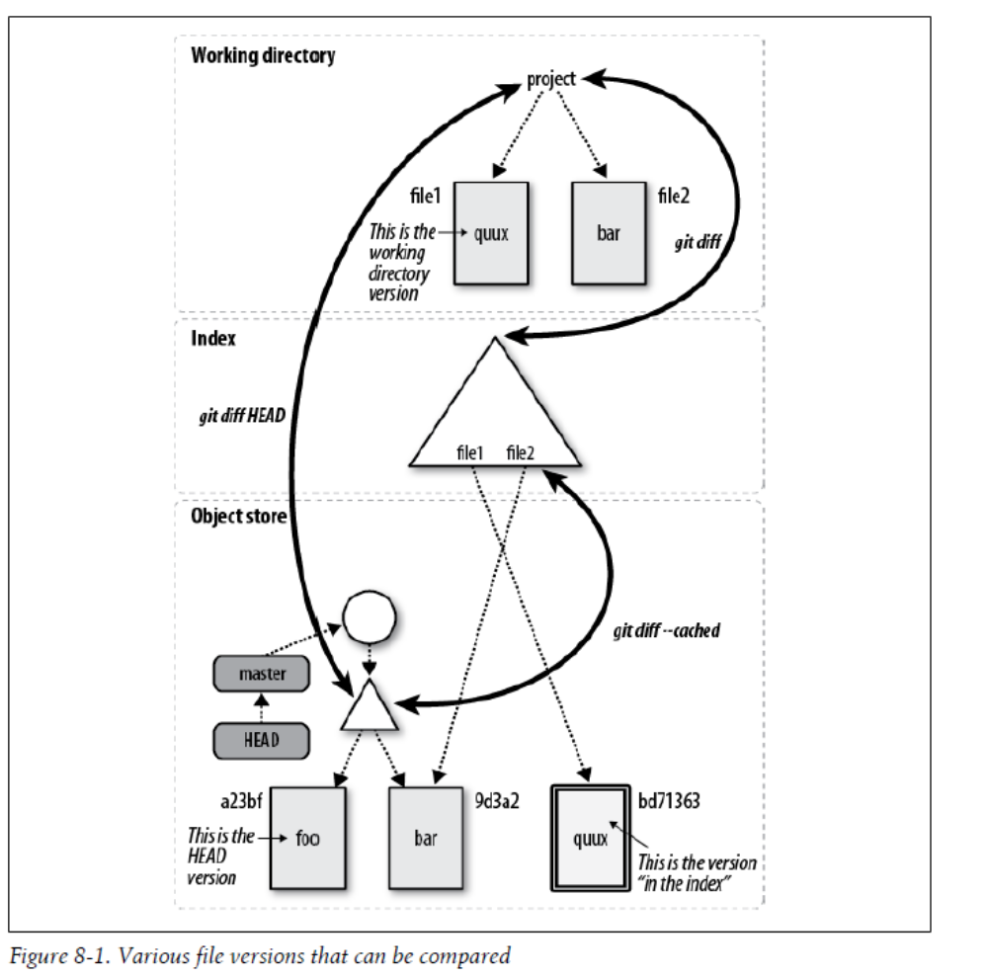

In addition to the four basic forms of git diff, there are myriad options as well. Here are a few of the more useful ones.

--M
The --M option detects renames and generates a simplified output that simply records the file rename rather than the complete removal and subsequent addition of the source file. If the rename is not a pure rename but also has some additional content changes, Git calls those out.

-w or --ignore-all-space
Both -w and --ignore-all-space compare lines without considering changes in
whitespace as significant.

--stat
The --stat option adds statistics about the difference between any two tree states.
It reports in a compact syntax how many lines changed, how many were added,
and how many were elided.

--color
The --color option colorizes the output; a unique color represents each of the different types of changes present in the diff.

Finally, the git diff may be limited to show diffs for a specific set of files or directories

To get both staged and unstaged changes, use git diff HEAD. The lack of symmetry is unfortunate and counterintuitive.

git diff and Commit Ranges

The git diff command supports a double-dot syntax to represent the difference between two commits. Thus, the following two commands are equivalent:
$ git diff master bug/pr-1
$ git diff master..bug/pr-1

Unfortunately, the double-dot syntax in git diff means something quite different from
the same syntax in git log, which you learned about in Chapter 6.

Some points to keep in mind for the following example:

• git diff doesn’t care about the history of the files it compares or anything about
Branches

• git log is extremely conscious of how one file changed to become another—for example, when two branches diverged and what happened on each branch The log and diff commands perform two fundamentally different operations. Whereas log operates on a set of commits, diff operates on two different end points.

If you type git log -p master..bug/pr-1, you will see one commit, because the syntax master..bug/pr-1 represents all those commits in bug/pr-1 that are not also in master. The command traces back to the point where bug/pr-1 diverged from master, but it does not look at anything that happened to master since that point.

$ git log -p master..bug/pr-1

In contrast, git diff master..bug/pr-1 shows the total set of differences between the two trees represented by the heads of the master and bug/pr-1 branches. History doesn’t matter; only the current state of the files does.

$ git diff master..bug/pr-1

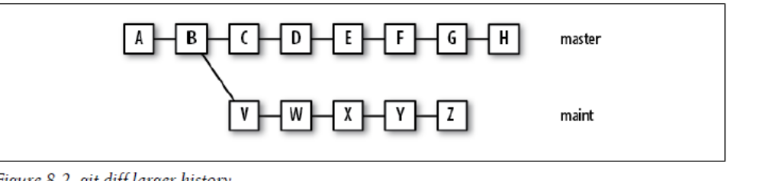

In this case, git log master..maint represents the five individual commits V, W, ..., Z. On the other hand, git diff master..maint represents the differences in the trees at H and Z, an accumulated 11 commits: C, D, ..., H and V, ..., Z

Similarly, both git log and git diff accept the form commit1...commit2 to produce a symmetrical difference. As before, however, git log commit1...commit2 and git diff commit1...commit2 yield different results.

As discussed in “Commit Ranges” on page 78 of Chapter 6, the command git log commit1...commit2 displays the commits reachable from either commit but not both. Thus, git log master...maint in the previous example would yield C, D, ...,H and V, ..., Z.

The symmetric difference in git diff shows the differences between a commit that is a common ancestor (or merge base) of commit1 and commit2. Given the same genealogy in Figure 8-2, git diff master...maint combines the changes in the commits V, W, ..., Z.

git diff with Path Limiting

By default, the command git diff operates on the entire directory structure rooted at a given tree object. However, you can leverage the same path limiting technique employed by git log to limit the output of git diff to a subset of the repository.

For example, at one point1 in the development of the Git’s own repository, git diff --stat displayed this:
$ git diff --stat master~5 master

To limit the output to just Documentation changes, you could instead use git diff --stat master~5 master Documentation:
$ git diff --stat master~5 master Documentation

Of course, you can view the diffs for a single file, too.
$ git diff master~5 master Documentation/git-add.txt

In the following example, also taken from Git’s own repository, the -S"string" searches the past 50 commits to the master branch for changes containing string.
$ git diff -S"octopus" master~50

Used with -S, often called the pickaxe, Git lists the diffs that contain a change in the number of times the given string is used in the diff. Conceptually, you can think of this as “Where is the given string either introduced or removed?”

CHAPTER 9 Merges

Working with Merge Conflicts

Git keeps track of problematic files by marking each one in the index as conflicted, or unmerged.

You can also use either the git status command or the git ls-files -u command to show the set of files that remain unmerged in your working tree

$ git status

$ git ls-files –u

The three-way merge marker lines (<<<<<<<<, ========, and >>>>>>>>) are automatically generated, but they’re just meant to be read by you, not (necessarily) a program. You should delete them with your text
editor once you resolve the conflict

git diff with conflicts
Git has a special, merge-specific variant of git diff to display the changes made against both parents simultaneously. In the example, it looks like this:
$ git diff
diff --cc hello
index e63164d,562080a..0000000
--- a/hello
+++ b/hello
@@@ -1,3 -1,3 +1,7 @@@
hello
++<<<<<<< HEAD:hello
+worlds
++=======
+ world
++>>>>>>> alt:hello
Yay!

What does it all mean? It’s the simple combination of two diffs: one versus the first parent, called HEAD, and one against the second parent, or alt. (Don’t be surprised if the second parent is an absolute SHA1 name representing some unnamed commit from some other repository!) To make things easier, Git also gives the second parent the special name MERGE_HEAD.

You can compare both the HEAD and MERGE_HEAD versions against the working directory (“merged”) version:
$ git diff HEAD
And then this:
$ git diff MERGE_HEAD

In newer versions of Git, git diff --ours is a synonym for git diff HEAD, because it shows the differences between “our” version and the merged version. Similarly, git diff MERGE_HEAD can be written as git diff --theirs. You can use git diff --base to see the combined set of changes since the merge base, which would otherwise be rather
awkwardly written as:
$ git diff $(git merge-base HEAD MERGE_HEAD)

If you line up the two diffs side by side, all the text except the + columns are the same, so Git prints the main text only once and prints the + columns next to each other.

The conflict found by git diff has two columns of information prepended to each line of output. A plus sign in a column indicates a line addition, a minus sign indicates a line removal, and a blank indicates a line with no change. The first column shows what’s changing versus your version, and the second column shows what’s changing versus the other version. The conflict marker lines are new in both versions, so they get a ++. The world and worlds lines are new only in one version or the other, so they have just a single + in the corresponding column.

Running git diff on a conflicted file only shows you the sections that really have a conflict. In a large file with numerous changes scattered throughout, most of those changes don’t have a conflict; either one side of the merge changed a particular section or the other side did. When you’re trying to resolve a conflict, you rarely care about those sections, so git diff trims out uninteresting sections using a simple heuristic: if a section has changes versus only one side, that section isn’t shown.

This optimization has a slightly confusing side effect: once you resolve something that used to be a conflict by simply picking one side or the other, it stops showing up. That’s because you modified the section so that it only changes one side or the other (i.e., the side that you didn’t choose), so to Git it looks just like a section that was never conflicted at all.

This is really more a side effect of the implementation than an intentional feature, but you might consider it useful anyway: git diff shows you only those sections of the file that are still conflicted, so you can use it to keep track of the conflicts you haven’t fixed yet.

git log with conflicts

While you’re in the process of resolving a conflict, you can use some special git log options to help you figure out exactly where the changes came from and why. Try this:
$ git log --merge --left-right –p

This command shows all the commits in both parts of the history that affect conflicted files in your merge, along with the actual changes each commit introduced. If you wondered when, why, how, and by whom the line worlds came to be added to the file, you can see exactly which set of changes introduced it.

The options provided to git log are as follows:
• --merge shows only commits related to files that produced a conflict
• --left-right displays < if the commit was from the “left” side of the merge (“our” version, the one you started with), or > if the commit was from the “right” side of the merge (“their” version, the one you’re merging in)
• -p shows the commit message and the patch associated with each commit

If your repository were more complicated and several files had conflicts, you could also provide the exact filename(s) you’re interested in as a command line option, like this:
$ git log --merge --left-right -p hello

The examples here have been kept small for demonstration purposes. Of course, reallife situations are likely to be significantly larger and more complex. One technique to mitigate the pain of large merges with nasty, extended conflicts is to use several small commits with well-defined effects contained to individual concepts. Git handles small commits well, so there is no need to wait until the last minute to commit large, widespread changes. Smaller commits and more frequent merge cycles reduce the pain of conflict resolution.

How Git Keeps Track of Conflicts

How exactly does Git keep track of all the information about a conflicted merge? There are several parts:

• .git/MERGE_HEAD contains the SHA1 of the commit you’re merging in. You don’t really have to use the SHA1 yourself; Git knows to look in that file whenever you talk about MERGE_HEAD.

• .git/MERGE_MSG contains the default merge message used when you git commit after resolving the conflicts.

• The Git index contains three copies of each conflicted file: the merge base, “our” version, and “their” version. These three copies are assigned respective stage numbers 1, 2, and 3.

• The conflicted version (merge markers and all) is not stored in the index. Instead, it is stored in a file in your working directory. When you run git diff without any parameters, the comparison is always between what’s in the index with what’s in your working directory.

To see how the index entries are stored, you can use the git ls-files plumbing command as follows:

$ git ls-files -s
100644 ce013625030ba8dba906f756967f9e9ca394464a 1 hello
100644 e63164d9518b1e6caf28f455ac86c8246f78ab70 2 hello
100644 562080a4c6518e1bf67a9f58a32a67bff72d4f00 3 hello

The -s option to git ls-files shows all the files with all stages. If you want to see only the conflicted files, use the -u option instead.

In other words, the hello file is stored three times, and each has a different hash corresponding to the three different versions. You can look at a specific variant by using git cat-file:

$ git cat-file -p e63164d951
hello
worlds
Yay!

You can also use some special syntax with git diff to compare different versions of the file. For example, if you want to see what changed between the merge base and the version you’re merging in, you can do this:
$ git diff :1:hello :3:hello

Using the stage numbers to name a version is different from git diff --theirs, which shows the differences between their version and the resulting, merged (or still conflicted) version in your working directory. The merged version is not yet in the index, so it doesn’t even have a number.

Finishing Up a Conflict Resolution
Let’s make one last change to the hello file before declaring it merged:
$ cat hello
hello
everyone
Yay!
Now that the file is fully merged and resolved, git add reduces the index to just a single copy of the hello file again:
$ git add hello
$ git ls-files -s
100644 ebc56522386c504db37db907882c9dbd0d05a0f0 0 hello

That lone 0 between the SHA1 and the path name tells you that the stage number for a nonconflicted file is zero.

You must work through all the conflicted files as recorded in the index. You cannot commit as long as there is an unresolved conflict. Therefore, as you fix the conflicts in a file, run git add (or git rm, git update-index, etc.) on the file to clear its conflict status.

Be careful not to git add files with lingering conflict markers. Although that will clear the conflict in the index and allow you to commit, your file won’t be correct.

You should notice three interesting things when you look at a merge commit:

• There is a new, second line in the header that says Merge:. Normally there’s no need to show the parent of a commit in git log or git show, since there is only one parent and it’s typically the one that comes right after it in the log. But merge commits typically have two (and sometimes more) parents, and those parents are important to understanding the merge. Hence, git log and git show always print
the SHA1 of each ancestor.

• The automatically generated commit log message helpfully notes the list of files that conflicted. This can be useful later if it turns out a particular problem was caused by your merge. Usually, problems caused by a merge are caused by the files that had to be merged by hand.

• The diff of a merge commit is not a normal diff. It is always in the combined diff or “conflicted merge” format. A successful merge in Git is considered to be no change at all; it is simply the combination of other changes that already appeared in the history. Thus, showing the contents of a merge commit shows only the parts that are different from one of the merged branches, not the entire set of changes.

Aborting or Restarting a Merge

Prior to executing the final git commit on the merge commit, use:
$ git reset --hard HEAD

If you want to abort or discard the merge after it has finished (that is, after it’s introduced a new merge commit), use the command:

$ git reset --hard ORIG_HEAD

Prior to beginning the merge operation, Git saves your original branch HEAD in the ORIG_HEAD ref for just this sort of purpose

If you have botched a conflict resolution and want to return to the original conflict state before trying to resolve it again, you can use the command git checkout -m.

Merge Strategies
You can always find the merge base between two or more branches by using git merge-base. It is possible for there to be more than one equally valid merge base for a set of branches.

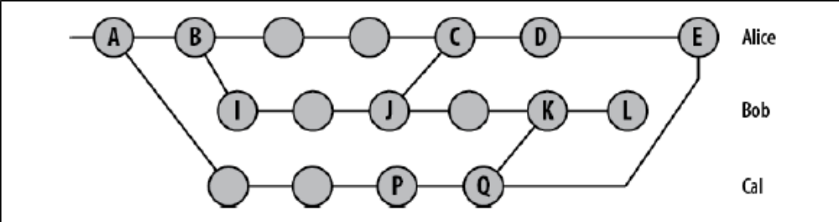

Next, Alice realizes that Bob has done some more work, L, and wants to merge from him again. What’s the merge base (between L and E) this time?

Unfortunately, the answer is ambiguous. If you trace all the way back up the tree, you might think the original revision from Cal is a good choice. But that doesn’t really make sense: both Alice and Bob now have Cal’s newest revision. If you ask for the differences from Cal’s original revision to Bob’s latest then it will also include Cal’s newer changes, which Alice already has, which is likely to result in a merge conflict.

What if you use Cal’s latest revision as the base? It’s better, but still not quite right: if you take the diff from Cal’s latest to Bob’s latest, you get all Bob’s changes. But Alice already has some of Bob’s changes, so you’ll probably get a merge conflict there, too.

And what if you use the version that Alice last merged from Bob, version J? Creating a diff from there to Bob’s latest will include only the newest changes from Bob, which is what you want. But it also includes the changes from Cal, which Alice already has!

What to do?

Hence, the developers generalized, parameterized, and introduced alternate, configurable merge strategies to handle different scenarios.
Let’s look at the various strategies and see how to apply each one.

Degenerate Merges
There are two common degenerate scenarios that lead to merges and are called already up-to-date and fast-forward. Because neither of these scenarios actually introduces a new merge commit after performing the git merge,1 some might consider them not to be true merge strategies.

• Already up-to-date. When all the commits from the other branch (its HEAD) are already present in your target branch, even if it has advanced on its own, the target branch is said to be already up-to-date. As a result, no new commits are added to your branch.

• Fast-forward. A fast-forward merge happens when your branch HEAD is already fully present and represented in the other branch. This is the inverse of the Already upto-date case. Because your HEAD is already present in the other branch (likely due to a common ancestor), Git simply tacks on to your HEAD the new commits from the other branch. Git then moves your branch HEAD to point to the final, new commit index and your working directory are also adjusted accordingly to reflect the new,final commit state. The fast-forward case is particularly common on tracking branches because they
simply fetch and record the remote commits from other repositories. Your local tracking branch HEADs will always be fully present and represented, because that is where the branch HEAD was after the previous fetch operation. See Chapter 12 for more details.

Normal Merges
These merge strategies all produce a final commit, added to your current branch, that
represents the combined state of the merge.

• Resolve. The resolve strategy operates on only two branches, locating the common
ancestor as the merge basis and performing a direct three-way merge by applying
the changes from the merge base to the tip of the other branch HEAD onto the current
branch. This method makes intuitive sense.
• Recursive. The recursive strategy is similar to the resolve strategy in that it can only
join two branches at once. However, it is designed to handle the scenario where
there is more than one merge base between the two branches. In these cases, Git
forms a temporary merge of all of the common merge bases and then uses that as
the base from which to derive the resulting merge of the two given branches via a
normal three-way merge algorithm.
The temporary merge basis is thrown away, and the final merge state is committed
on your target branch.
• Octopus. The octopus strategy is specifically designed to merge together more than
two branches simultaneously. Conceptually, it is fairly simple; internally, it calls
the recursive merge strategy multiple times, once for each branch you are merging.
However, this strategy cannot handle a merge that requires any form of conflict
resolution that would necessitate user interaction. In such a case, you are forced
to do a series of normal merges, resolving the conflicts one step at a time.

Recursive merges
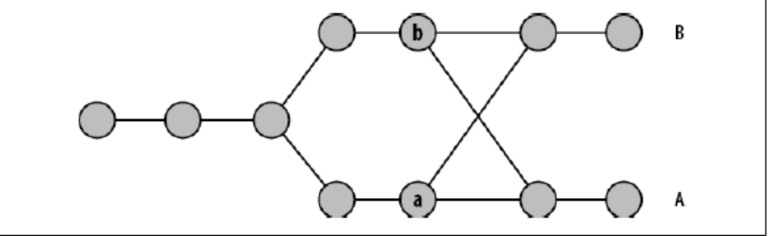

The nodes a and b are both merge bases for a merge between A and B. Either one could be used as the merge base and yield reasonable results. In this case, the recursive strategy would merge a and b into a temporary merge base, using that as the merge base for A and B.

Because a and b could have the same problem, merging them could require another merge of still older commits. That is why this algorithm is called recursive.

Specialty Merges

There are two special merge strategies that you should be aware of because they can sometimes help you solve strange problems. Feel free to skip this section if you don’t have a strange problem. The two special strategies are ours and subtree.

These merge strategies each produce a final commit, added to your current branch, that represents the combined state of the merge.

- Ours. The ours strategy merges in any number of other branches, but it actually discards changes from those branches and uses only the files from the current branch. The result of an ours merge is identical to the current HEAD, but any other named branches are also recorded as commit parents.

This is useful if you know you already have all the changes from the other branches but want to combine the two histories anyway. That is, it lets you record that you have somehow performed the merge, perhaps directly by hand, and that future Git operations shouldn’t try to merge the histories again. Git can treat this as real merge no matter how it came to be.

- Subtree. The subtree strategy merges in another branch, but everything in that branch is merged into a particular subtree of the current tree. You don’t specify which subtree; Git determines that automatically.

Applying Merge Strategies

Because resolve is no longer Git’s default, if Alice wanted to use it then she would make an explicit request:
$ git merge -s resolve Bob

In 2005, Fredrik Kuivinen contributed the new recursive merge strategy, which has since become the default. It is more general than resolve and has been shown to result in fewer conflicts, without fault, on the Linux kernel. It also handles merges with renames quite well.

Git can make squash commits if desired. Just give the --squash option to git merge or git pull. Beware, however! Squashing commits will upset Git’s history, and that will complicate future merges because the squashed comments alter the history of commits (see Chapter 10).

CHAPTER 10 Altering Commits

Git provides several tools and commands specifically designed to help you modify and improve the commit history cataloged within your repository.

Using git reset
The git reset command changes your repository and working directory to a known state. Specifically, git reset adjusts the HEAD ref to a given commit and, by default, updates the index to match that commit. If desired, git reset can also modify your working directory to mirror the revision of your project represented by the given commit.

However, the whole point of this command is to establish and recover known states for the HEAD, index, and working directory.

The git reset command has three main options: --soft, --mixed, and –hard

git reset --soft commit
The --soft changes the HEAD ref to point to the given commit. The contents of your
index and working directory are left unchanged. This version of the command has
the “least” effect, changing only the state of a symbolic reference so it points to a new commit.
git reset --mixed commit
--mixed changes HEAD to point to the given commit. Your index contents are also
modified to align with the tree structure named by commit, but your working
directory contents are left unchanged. This version of the command leaves your
index as if you had just staged all the changes represented by commit, and it tells
you what remains modified in your working directory.
Note that --mixed is the default mode for git reset.

git reset --hard commit
This variant changes the HEAD ref to point to the given commit. The contents of your
index are also modified to agree with the tree structure named by the named
commit. Furthermore, your working directory contents are changed to reflect the
state of the tree represented by the given commit.
When changing your working directory, the complete directory structure is altered
to correspond to the given commit. Modifications are lost and new files are removed.
Files that are in the given commit but no longer exist in your working directory are
reinstated.

The git reset command also saves the original HEAD value in the ref ORIG_HEAD. This is useful, for example, if you wish to use that original HEAD’s commit log message as the basis for some follow-up commit.

In terms of the object model, git reset moves the current branch HEAD within the commit graph to a specific commit. If you specify --hard, your working directory is transformed as well.

As suggested, to avoid committing the file, use git reset HEAD to unstage it:
$ git ls-files
foo.c
main.c
$ git reset HEAD foo.c
$ git ls-files
main.c

Although the examples all use HEAD in some form, you can apply git reset to any
commit in the repository. For example, to eliminate several commits on your current
branch, you could use git reset --hard HEAD~3 or even git reset --hard master~3.

But be careful. Just because you can name other commits using a branch name, this is
not the same as checking the branch out. Throughout the git reset operation, you
remain on the same branch. You can alter your working directory to look like the head
of a different branch, but you are still on your original branch.

Using git cherry-pick
The command git cherry-pick commit applies the changes introduced by the named
commit on the current branch. It will introduce a new, distinct commit. Strictly speaking,
using git cherry-pick doesn’t alter the existing history within a repository; instead, it
adds to the history.

As with other Git operations that introduce changes via the process of applying a diff,
you may need to resolve conflicts to fully apply the changes from the given commit.

The command git cherry-pick is typically used to introduce particular commits from one branch within a repository onto a different branch. A common use is to forward or back-port commits from a maintenance branch to a development branch.

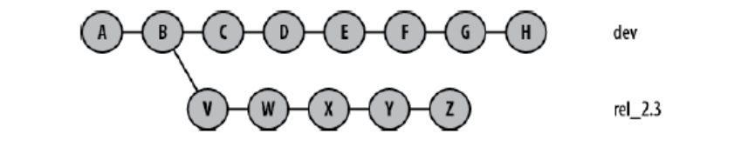

During the course of normal development, a bug is fixed on the development line with
commit F. If that bug turns out to be present in the 2.3 release also, the bug fix, F, can
be made to the rel_2.3 branch using git cherry-pick:
$ git checkout rel_2.3
$ git cherry-pick dev~2 # commit F, above

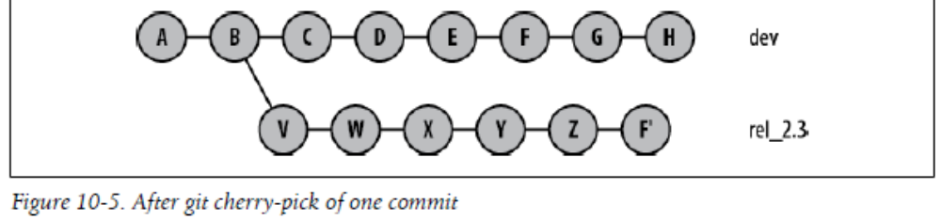

In Figure 10-5, commit F' is substantially similar to commit F, but it is a new commit and will have to be adjusted—perhaps with conflict resolutions—to account for its application to commit Z rather than commit E.

Originally, the git cherry-pick command selected and reapplied one commit at a time. However, in later versions of Git, git cherry-pick allowed a range of commits to be selected and reapplied in a single command. For example, the following command:

# on branch master
$ git cherry-pick X..Z

would apply new commits X', Y', and Z' on the master branch. This is particularly handy in porting or moving a large sequence of commits from one line of development to another without necessarily using the entire source branch at one time.

Using git revert

The git revert commit command is substantially similar to the command git cherry-pick commit with one important difference: it applies the inverse of the given commit. Thus, this command is used to introduce a new commit that reverses the effects of a given commit.

Like git cherry-pick, the revert doesn’t alter the existing history within a repository. Instead it adds a new commit to the history.

reset, revert, and checkout

The three Git commands reset, revert, and checkout can be somewhat confusing, because all appear to perform similar operations

If you want to change to a different branch, use git checkout. Your current branch and HEAD ref change to match the tip of the given branch

The git reset command does not change your branch. However, if you supply the
name of a branch, it will change the state of your current working directory to look like
the tip of the named branch. In other words, git reset is intended to reset the current
branch’s HEAD reference.

The confusion with git checkout is due to its additional ability to extract a file from
the object store and put it into your working directory, possibly replacing a version in
your working directory in the process. Sometimes the version of that file is one corresponding
to the current HEAD version and sometimes it is an earlier version.

Checkout file.c from index
$ git checkout -- path/to/file.c
# Checkout file.c from rev v2.3
$ git checkout v2.3 -- some/file.c

Git calls this “checking out a path.”

In the former case, obtaining the current version from the object store appears to be a form of a “reset” operation—that is, your local working directory edits of the file are discarded because the file is reset to its current, HEAD version. That is double-plus ungood Git thinking.

In the latter case, an earlier version of the file is pulled out of the object store and placed into your working directory. This has the appearance of being a “revert” operation on the file. That, too, is double-plus ungood Git thinking.

In both cases, it is improper to think of the operation as a Git reset or a revert. In both cases, the file is “checked out” from a particular commit: HEAD and v2.3, respectively.

The git revert command works on full commits, not on files

Changing the Top Commit

One of the easiest ways to alter the most recent commit on your current branch is with git commit –amend

Rebasing Commits

The git rebase command is used to alter where a sequence of commits is based. This
command requires at least the name of the other branch onto which your commits will
be relocated. By default, the commits from the current branch that are not already on
the other branch are rebased.

$ git checkout topic
$ git rebase master
or
$ git rebase master topic

In the context of a repository that you have cloned from somewhere else, it is common
to forward port your development branch or branches onto the origin/master tracking
branch like this using the git rebase operation

The git rebase command may also be used to completely transplant a line of development
from one branch to an entirely different branch using the --onto option.

For example, suppose you’ve developed a new feature on the feature branch with the
commits P and Q, which were based on the maint branch as shown in Figure 10-14. To
transplant the P and Q commits on the feature branch from the maint to the master
branch, issue the command:
$ git rebase --onto master maint^ feature

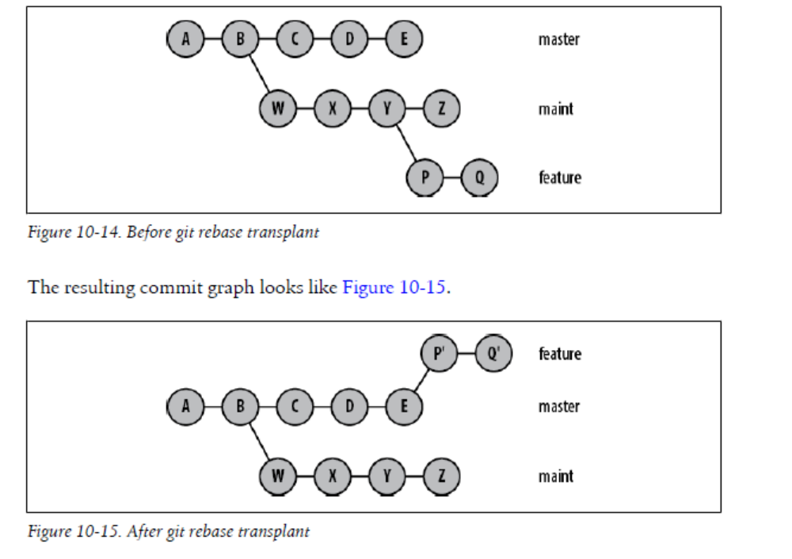
The rebase operation relocates commits one at a time from each respective original
commit location to a new commit base. As a result, each commit that is moved might
have conflicts to resolve

Finally, if the rebase operation turns out to be the totally wrong thing to do,
git rebase --abort abandons the operation and restores the repository to the state
prior to issuing the original git rebase.

Using git rebase –i

Reordering, editing, removing, squashing multiple commits into one, and splitting a
commit into several are all easily performed by the git rebase command using the -i
or --interactive option. This command allows you to modify the commits that make
up a branch and place them back onto the same branch or onto a different branch.

rebase Versus merge

You might think that executing the command:
# Move onto tip of master the dev branch
$ git rebase master dev

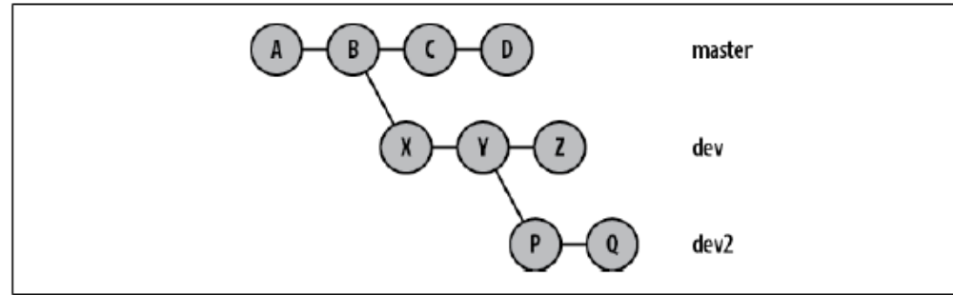

would yield the graph in Figure 10-17. But it does not

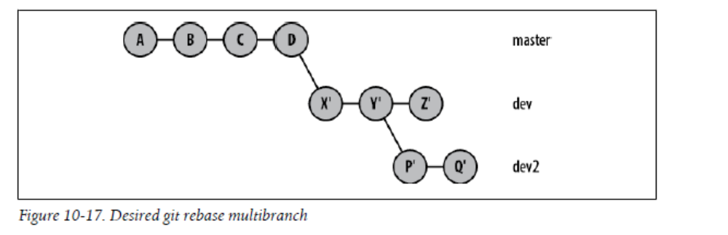

This says that Git applied the commits for X, Y, and Z only. Nothing was said about P
or Q, and instead you obtain the graph in Figure 10-18.

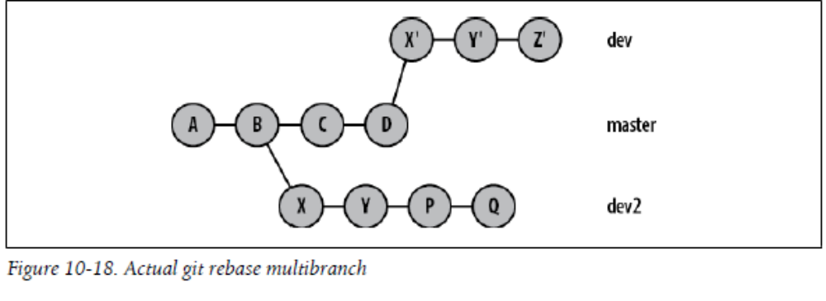

The commits X', Y', and Z' are the new versions of the old commits that stem from B. The old X and Y commits both still exist in the graph because they are still reachable from the dev2 branch. However, the original Z commit has been removed because it is no longer reachable. The branch name that was pointing to it has been moved to the new version of that commit.

But remember, these are different commits that do essentially the same change. If you merge a branch with one of the new commits into another branch that has one of the old commits, Git has no way of knowing that you’re applying the same change twice. The result is duplicate entries in git log, most likely a merge conflict, and general confusion. It’s a situation that you should find a way to clean up.

If this resulting graph is actually what you want, then you’re done. More likely, moving the entire branch (including subbranches) is what you really want. To achieve that graph, you will, in turn, need to rebase the dev2 branch on the new Y' commit on the dev branch:
$ git rebase dev^ dev2

And this is the graph shown in Figure 10-17.

Another situation that can be extremely confusing is rebasing a branch that has a merge
on it. For example, suppose you had a branch structure like that shown in Figure 10-19.

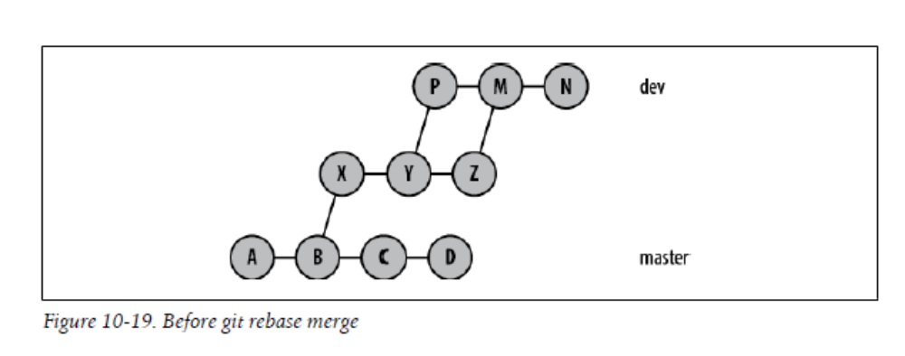

If you want to move the entire dev branch structure from commit N down through to
commit X off of B and onto D, as shown in Figure 10-20, then you might expect simply
to use the command git rebase master dev.

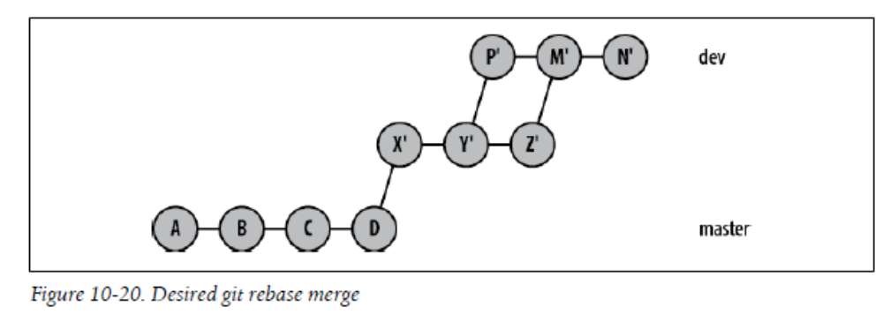

Again, however, that command yields some surprising results:
$ git rebase master dev

Git needs to move the portion of the graph reachable from dev back to the merge base
at B, so it found the commits in the range master..dev. To list all those commits, Git
performs a topological sort on that portion of the graph to produce a linearized
sequence of all the commits in that range. Once that sequence has been determined,
Git applies the commits one at a time starting on the target commit, D. Thus, we say
that “Rebase has linearized the original branch history (with merges) onto the master
branch,” as shown in Figure 10-21.

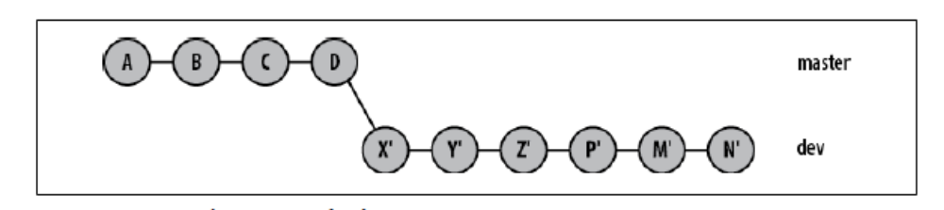

Again, if that is what you wanted or if you don’t care that the graph shape has been altered, then you are done. But if in such cases you want to explicitly preserve the branching and merging structure of the entire branch being rebased, then use the --preserve-merges option.
# This option is a version 1.6.1 feature
$ git rebase --preserve-merges master dev

And this looks like the graph in Figure 10-20.

The important concepts to remember are:
• Rebase rewrites commits as new commits.
• Old commits that are no longer reachable are gone.
• Any user of one of the old, pre-rebase commits might be stranded.
• If you have a branch that uses a pre-rebase commit, you might need to rebase it in
turn.
• If there is a user of a pre-rebase commit in a different repository, he still has a copy
of that commit even though it has moved in your repository; the user will now have
to fix up his commit history, too.

CHAPTER 11 The Stash and the Reflog

The Stash

The stash is a mechanism for capturing your work in progress, allowing you to save it and return to it later when convenient

the stash is a quick convenience mechanism that allows a complete and thorough capturing of your index and working directory in one simple command. It leaves your repository clean, uncluttered, and ready for an alternate development direction

The default and optional operation to git stash is save. Git also supplies a default log message when saving a stash, but you can supply your own to better remind you what you were doing. Just supply it in the command after the then-required save argument:

$ git stash save "WIP: Doing real work on my stuff"

The acronym WIP is a common abbreviation used in these situations meaning “work in progress.

The git stash save command will save your current index and working directory state and clear them out so that they again match the head of your current branch

Instead, the contents of your index and working directory are actually stored as independent, regular commits and are accessible through the ref refs/stash.

As you might surmise by the use of pop to restore your state, the two basic stash commands, git stash save and git stash pop, implement a stack of stash states.

The git stash pop command restores the context saved by a previous save operation on top of your current working directory and index. And by restore here, I mean that the pop operation takes the stash content and merges those changes into the current state rather than just overwriting or replacing files.

Because the application of the saved context can be performed on top of a different commit, merging may be required, complete with possible user resolution of any conflicts.

After a successful pop operation, Git will automatically remove your saved state from the stack of saved states. That is, once applied, the stash state will be “dropped.”

Once you clear the merge conflicts and want to proceed, you should use the git stash drop to remove it from the stash stack. Otherwise, Git will maintain an ever growing1 stack of contexts.

If you just want to recreate the context you have saved in a stash state without dropping it from the stack, use git stash apply. Thus, a pop command is a successful apply followed by a drop

In fact, you can use git stash apply to apply the same saved stashed context onto several different commits prior to dropping it from the stack.

Git always numbers the stash entries with the most recent entry being zero. As entries get older, they increase in numerical order. And yes, the different stash entry names are stash@{0} and stash@{1}, as explained in “The Reflog” on page 189.

The git stash show command shows the index and file changes recorded for a given stash entry, relative to its parent commit.

$ git stash show

That summary may or may not be the extent of the information you sought. If not, adding -p to see the diffs might be more useful. Note that by default the git stash show command shows the most recent stash entry, stash@{0}.

Because the changes that contribute to making a stash state are relative to a particular commit, showing the state is a state-to-state comparison suitable for git diff, rather than a sequence of commit states suitable for git log. Thus, all the options for git diff may also be supplied to git stash show as well. As we saw previously, --stat is the default, but other options are valid, too. Here, -p is used to obtain the patch differences for a given stash state.

$ git stash show -p stash@{1}

In this case, add the --include-untracked option on your git stash so that it also stashes your new, untracked files along with the rest of your modifications. That will ensure a completely clean working directory for the pull.

The --all option will gather up the untracked files as well as the explicitly ignored files from the .gitignore and exclude files

Finally, for more complex stashing operations where you wish to selectively choose
which hunks should be stashed, use the -p or --patch option.

$ git commit --dry-run

Nonetheless, you may still want to recover the work you stashed. In situations like this, git offers the git stash branch command to help you. This command converts the contents of a saved stash into a new branch based on the commit that was current at the time the stash entry was made.

Due to other development reasons, more commits are made and the branch drifts away from the d5ef6c9 state.

$ git log --pretty=one --abbrev-commit

And although the stashed work is available, it doesn’t apply cleanly to the current master branch.
$ git stash list

$ git stash branch mod

There are several important points to notice here. First, notice that the branch is based on the original commit d5ef6c9, and not the current head commit 2c2af13

Second, because the stash is always reconstituted against the original commit, it will always succeed and hence will be dropped from the stash stack.

Finally, reconstituting the stash state doesn’t automatically commit any of your changes onto the new branch. All the stashed file modifications (and index changes, if desired) are still left in your working directory on the newly created and checked out branch.

$ git merge mod

As some parting advice on the git stash command, let me leave you with this analogy: you name your pets and you number your livestock. So branches are named and stashes are numbered. The ability to create stashes might be appealing, but be careful not to overuse it and create too many stashes. And don’t just convert them to named branches to make them linger!

The Reflog

The reflog is a record of changes to the tips of branches within nonbare repositories. Every time an update is made to any ref, including HEAD, the reflog is updated to record how that ref has changed. Think of the reflog as a trail of bread crumbs showing where you and your refs have been. With that analogy, you can also use the reflog to follow your trail of crumbs and trace back through your branch manipulations.

Fundamentally, any Git operation that modifies a ref or changes the tip of a branch is recorded.

$ git reflog show
a44d980 HEAD@{0}: reset: moving to master
79e881c HEAD@{1}: commit: last foo chang

Although the reflog records transactions for all refs, git reflog show displays the transactions for only one ref at a time. The previous example shows the default ref, HEAD. If you recall that branch names are also refs, you will realize that you can also get the reflog for any branch as well. From the previous example, we can see that there is also a branch named fred, so we can display its changes in another command:

$ git reflog fred
a44d980 fred@{0}: reset: moving to master
79e881c fred@{1}: commit: last foo change
a44d980 fred@{2}: branch: Created from HEAD

Thus, HEAD@{0} is the most recent entry, HEAD@{1} records where HEAD was just prior to that, etc. The oldest entry, here HEAD@{13}, is actually the very first commit in this repository.

Thus, HEAD@{3} doesn’t necessarily mean the third prior git commit operation. More accurately, it means the third prior visited or referenced commit.

Botch a git merge and want try again? Use git reset HEAD@{1}. Add --hard if desired.

Git also supports more English-like qualifiers for the part of the reference within braces.

$ git log 'HEAD@{last saturday}'

Git supports a fairly wide variety of date-based qualifiers for refs. These include words like yesterday, noon, midnight, tea,2 weekdays, month names, A.M. and P.M. indicators, absolute times or dates, and relative phrases like last monday, 1 hour ago, 10 minutes ago, and combinations of these phrases such as 1 day 2 hours ago. And, finally, if you omit the actual ref name and just use the @{...} form, the current branch name is assumed. Thus, while on the bugfix branch, using just @{noon} refers to bug fix@{noon}.

The Git tool responsible for understanding references is git rev-parse. Its manpage is extensive and details more than you would ever care to know about how refs are interpreted. Good luck!

Also remember that the notion of time is local and relative to your repository

One last warning. Don’t let the shell trick you. There is a significant difference between these two commands:

# Bad!
$ git log dev@{2 days ago}

# Likely correct for your shell
$ git log 'dev@{2 days ago}'

The former, without single quotes, provides multiple command line arguments to your shell, whereas the latter, with quotes, passes the entire ref phrase as one command line argument. Git needs to see the ref as one word from the shell. To help simplify the word break issue, Git allows several variations:

# These should all be equivalent
$ git log 'dev@{2 days ago}'
$ git log dev@{2.days.ago}
$ git log dev@{2-days-ago}

One more concern to address. If Git is maintaining a transaction history of every operation performed on every ref in the repository, doesn’t the reflog eventually become huge?

Luckily, no. Git automatically runs a garbage collection process occasionally. During this process, some of the older reflog entries are expired and dropped. Normally, a commit that is otherwise not referenced or reachable from some branch or ref will be expired after a default of 30 days, and commits that are reachable expire after a default of 90 days.

If that schedule isn’t ideal, the configuration variables gc.reflogExpireUnreachable and gc.reflogExpire, respectively, can be set to alternate values in your repository. You can use the command git reflog delete to remove individual entries, or use the command git reflog expire to directly cause entries older than a specified time to be immediately removed. It can also be used to forcefully expire the reflog.
$ git reflog expire --expire=now --all
$ git gc

One last implementation detail: reflogs are stored under the .git/logs directory. The file .git/logs/HEAD contains the history of HEAD values, whereas the subdirectory .git/logs/refs/ contains the history of all refs, including the stash. The sub-subdirectory .git/logs/refs/heads contains the history for branch heads.

All the information stored in the reflogs, specifically everything under the .git/logs directory, is ultimately transitory and expendable. Throwing away the .git/logs directory or turning the reflog off harms no Git-internal data structure; it simply means references like master@{4} can’t be resolved.

Conversely, having the reflog enabled introduces references to commits that might otherwise be unreachable. If you are trying to clean up and shrink your repository size, removing the reflog may enable the removal of otherwise unreachable (i.e., irrelevant) commits.

CHAPTER 13 Repository Management

A Git repository is either a bare or a development (nonbare) repository

A development repository is used for normal, daily development. It maintains the
notion of a current branch and provides a checked out copy of the current branch in a
working directory. All of the repositories mentioned in the book so far have been
development repositories.

In contrast, a bare repository has no working directory and shouldn’t be used for normal
development. A bare repository has no notion of a checked out branch, either. Think
of a bare repository as simply the contents of the .git directory. In other words, you
shouldn’t make commits in a bare repository.

A bare repository might seem to be of little use, but its role is crucial: to serve as an
authoritative focal point for collaborative development. Other developers clone and
fetch from the bare repository and push updates to it. We’ll work through an example
later in this chapter that shows how all this works together.

If you issue git clone with the --bare option, Git creates a bare repository; otherwise,
a development repository is created.

The command git init creates a new and empty repository, and that new repository can come in both development and bare variants. Also, be aware of how the --bare flag affects the directory that is initialized:

By default, Git enables a reflog (a record of changes to refs) on development repositories
but not on bare repositories. This again anticipates that development will take place in
the former and not in the latter. By the same reasoning, no remotes are created in a bare
repository.

If you set up a repository into which developers push changes, it should be bare. In
effect, this is a special case of the more general best practice that a published repository
should be bare.

Repository Clones
In normal git clone use, the local, development branches of the original repository, stored within refs/heads/, become remote-tracking branches in the new clone under refs/remotes/.

Tags from the original repository are copied into the clone, as are all objects that are reachable from the copied refs. However, repository-specific information such as hooks (see Chapter 15), configuration files, the reflog, and the stash of the original repository are not reproduced in the clone.

By default, each new clone maintains a link back to its parent repository via a remote called origin. However, the original repository has no knowledge of—nor does it maintain a link to—any clone. It is purely a one-way relationship.

The name “origin” isn’t special in any way. If you don’t want to use it, simply specify an alternate with the --origin name option during the clone operation.Git also configures the default origin remote with a default fetch refspec:
fetch = +refs/heads/*:refs/remotes/origin/*

Establishing this refspec anticipates that you want to continue updating your local repository by fetching changes from the originating repository. In this case, the remote repository’s branches are available in the clone on branch names prefixed with origin/, such as origin/master, origin/dev, or origin/maint.

In addition to git clone, other common Git commands that refer to remote repositories
are:
- git fetch
- git pull
- git push
- git ls-remote
Shows a list of references held by a given remote (on an upstream server). This
command indirectly answers the question “Is an update available?”

Tracking Branches

During a clone operation, Git creates a remote-tracking branch in the clone for each topic branch in the upstream repository. The set of remote-tracking branches is introduced in a new, separate namespace within the local repository that is specific to the remote being cloned. They are not branches in a remote repository. The local repository uses its remote-tracking branches to follow or track changes made in the remote repository.

All the operations that you can perform on a regular topic branch can also be performed
on a tracking branch. However, there are some restrictions and guidelines to observe.

Because remote-tracking branches are used exclusively to follow the changes from
another repository, you should effectively treat them as read only. You shouldn’t merge
or make commits onto a remote-tracking branch. Doing so would cause your remotetracking
branch to become out of sync with the remote repository. Worse, each future
update from the remote repository would likely require merging, making your clone
increasingly more difficult to manage. The proper management of tracking branches is
covered in more detail later in this chapter.

The refspec

Usually a ref is the name of a branch. A refspec maps branch names in the remote repository to branch names within your local repository.

Because a refspec must simultaneously name branches from the local repository and the remote repository, complete branch names are common in a refspec and are often required. In a refspec, you typically see the names of development branches with the refs/heads/ prefix and the names of remote-tracking branches with the refs/remotes/prefix.

The syntax of a refspec is:
[+]source:destination

It consists primarily of a source ref, a colon (:), and a destination ref. The whole format may be prefixed with an optional plus sign (+). If present, the plus sign indicates that the normal fast-forward safety check will not be performed during the transfer. Furthermore, an asterisk (*) allows a limited form of wildcard matching on branch names.

Refspecs are used by both git fetch and git push. The trick to using a refspec is to understand the data flow it specifies. The refspec itself is always source:destination, but the roles of source and destination depend on the Git operation being performed
This relationship is summarized in Table 12-1.

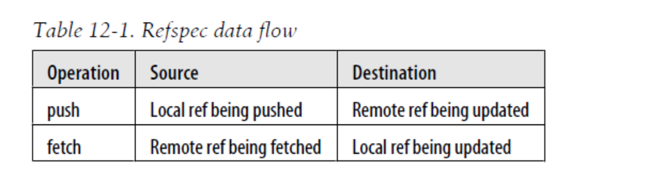
A typical git fetch command uses a refspec such as:
+refs/heads/*:refs/remotes/remote/*
This refspec might be paraphrased as follows:
All the source branches from a remote repository in namespace refs/heads/ are (i) mapped
into your local repository using a name constructed from the remote name and (ii) placed
under the refs/remotes/remote namespace.

Thus, during a typical git push command, the source branches from your repository are sent to the remote repository using a refspec such as:
+refs/heads/*:refs/heads/*

This refspec can be paraphrased as follows
- From the local repository, take each branch name found under the source namespace refs/heads/ and place it in a similarly named, matching branch under the destinationnamespace refs/heads/ in the remote repository.

The first refs/heads/ refers to your local repository (because you’re executing a push),
and the second refers to the remote repository. The asterisks ensure that all branches
are replicated

Make Your Own Origin Remote
Moreover, because the ~/public_html repository in your home directory was created using git init and not via a clone, it lacks an origin. In fact, it has no remote configured at all.

The command for manipulating remotes is git remote. This operation introduces a few new settings in the .git/config file

$ cat .git/config
$ git remote add origin /tmp/Depot/public_html

$ cat .git/config
[core]
repositoryformatversion = 0
filemode = true
bare = false
logallrefupdates = true
[remote "origin"]
url = /tmp/Depot/public_html
fetch = +refs/heads/*:refs/remotes/origin/*

Here, git remote added a new remote section called origin to our configuration

The remote establishes a link from your current repository to the remote repository found, in this case, at /tmp/Depot/public_html.git as recorded in the url value. As a convenience, the .git suffix is not required; both /tmp/Depot/public_html and /tmp/Depot/public_html.git will work. Now, within this repository, the name origin can be used as a shorthand reference for the remote repository found in the depot. Note that a default fetch refspec that follows branch name mapping conventions has
also been added.

Let’s complete the process of setting up the origin remote by establishing new remotetracking branches in the original repository to represent the branches from the remote repository. First, you can see that there is only one branch, as expected, called master

Now, use git remote update:
$ git remote update

Git introduced a new branch called origin/master into the repository. It is a remotetracking branch within the origin remote. Nobody does development in this branch. Instead, its purpose is to hold and track the commits made in the remote origin repository’s master branch. You could consider it your local repository’s proxy for commits made in the remote; eventually you can use it to bring those commits into your repository.

The phrase Updating origin, produced by the git remote update, doesn’t mean that the remote repository was updated. Rather, it means that the local repository’s notion of the origin has been updated based on information brought in from the remote repository

Rather than generically updating all remotes, you can restrict the operation to fetch updates
from a single remote by supplying the desired remote name on the git remote update command:

$ git remote update remote_name

Also, using the -f option when the remote is initially added causes an immediate fetch of from that remote repository:
$ git remote add -f origin repository

When the remote repository is on a physically different machine, a plumbing command
can be used to determine the branch information of the remote repository:
# Go to the actual remote repo and query it
$ git ls-remote origin

Bob can find out more information about the origin remote within his repository:
$ git remote show origin

The complete contents of the configuration file after a default clone show how it contains
the origin remote:
$ cat .git/config
[core]
repositoryformatversion = 0
filemode = true
bare = false
logallrefupdates = true
[remote "origin"]
url = /tmp/Depot/public_html.git
fetch = +refs/heads/*:refs/remotes/origin/*
[branch "master"]
remote = origin
merge = refs/heads/master

The fetch step
In the first fetch step, Git locates the remote repository. Because the command line did not specify a direct repository URL or a direct remote name, it assumes the default remote name, origin. The information for that remote is in the configuration file:

[remote "origin"]
url = /tmp/Depot/public_html.git
fetch = +refs/heads/*:refs/remotes/origin/*

Git now knows to use the URL /tmp/Depot/public_html as the source repository.
Furthermore, because the command line didn’t specify a refspec, Git will use all of the
fetch = lines from the remote entry. Thus, every refs/heads/* branch from the remote
will be fetched.

You don’t have to fetch all of the topic branches from the remote repository using the refs/heads/* wildcard form. If you want only a particular branch or two, list them explicitly:

[remote "newdev"]
url = /tmp/Depot/public_html.git
fetch = +refs/heads/dev:refs/remotes/origin/dev
fetch = +refs/heads/stable:refs/remotes/origin/stable

Git places the new commits in your repository on an appropriate remote-tracking branch and then tells you what mapping it uses to determine where the new commits belong:

From /tmp/Depot/public_html
3958f68..55c15c8 master -> origin/master

Those lines indicate that Git looked at the remote repository /tmp/Depot/public_html, took its master branch, brought its contents back to your repository, and placed them on your origin/master branch. This process is the heart of branch tracking.

The merge or rebase step
In the second step of the pull operation, Git performs a merge (the default), or a rebase operation
But how did Git know to merge those particular branches? The answer comes from the configuration file:
[branch "master"]
remote = origin
merge = refs/heads/master

Because the merge configuration value applies only during git pull, a manual application
of git merge at this point must name the merge source branch on the command
line. The branch is likely a remote-tracking branch name, such as this:

$ git merge origin/master

The command git pull --rebase will cause Git to rebase (rather than merge) your local-tracking branch onto the remote-tracking branch during only this pull. To make rebase the normal operation for a branch, set the branch.branch_name.rebase configuration variable to true:

[branch "mydev"]
remote = origin
merge = refs/heads/master
rebase = true
And with that, the merge (or rebase) step is also done.

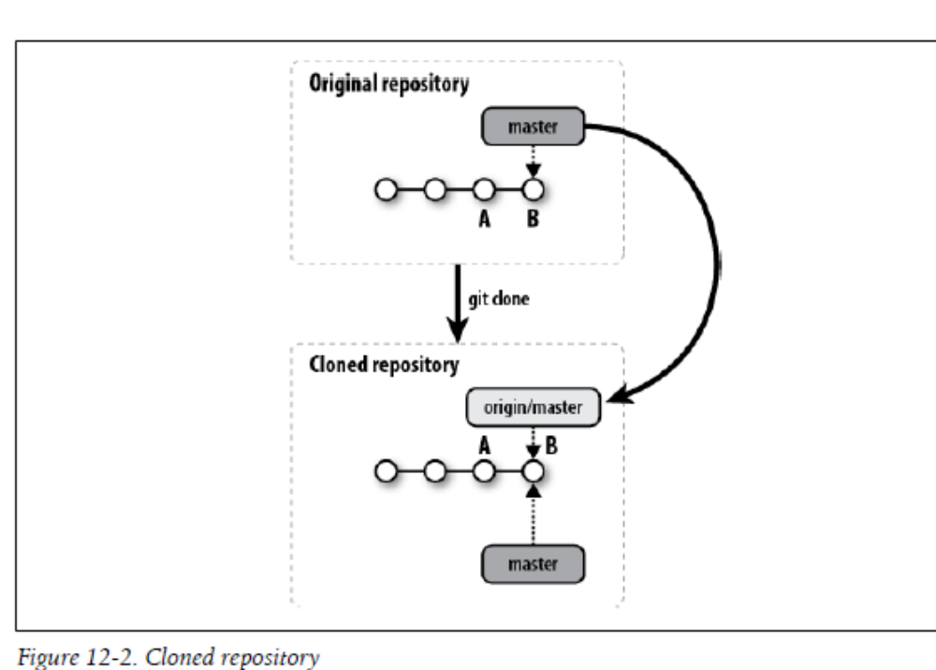

This picture illustrates some important results of the clone operation:
• All the commits from the original repository are copied to your clone; you could now easily retrieve earlier stages of the project from your own repository.
• The branch named master from the original repository is introduced into your clone on a new remote-tracking branch named origin/master.
• Within the new clone repository, the new origin/master branch is initialized to point to the master HEAD commit, which is B in the figure.
• A new local-tracking branch called master is created in your clone.
• The new master branch is initialized to point to origin/HEAD, the original
repository’s active branch HEAD. That happens to be origin/master, so it also points
to the exact same commit, B.

After cloning, Git selects the new master branch as the current branch and checks it
out for you. Thus, unless you change branches, any changes you make after a clone
will affect your master.

In terms of Git’s implementation, however, the dark shaded branch labels belong to the refs/heads/ namespace whereas, the lighter ones belong to refs/remotes/.

Alternate Histories

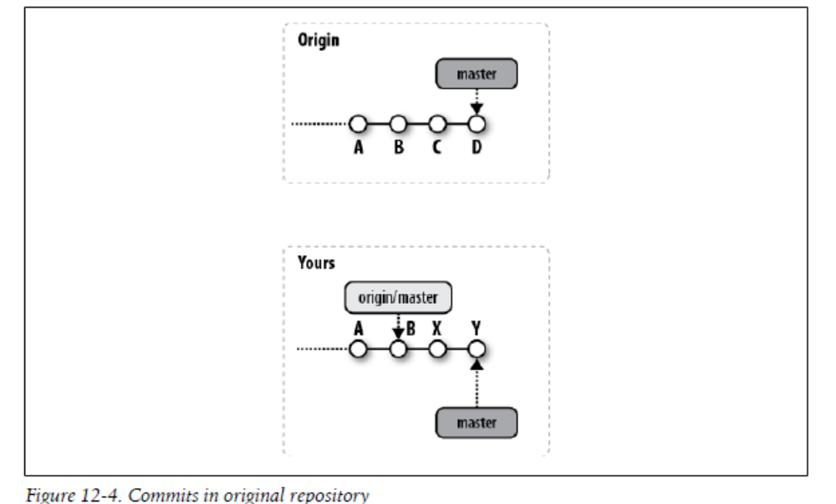

If you are developing in a repository model in which you have the ability to git push
your changes into the origin repository, then you might attempt to push your changes
at any time. This could create problems if some other developer has previously pushed
commits.

When you attempt your push, Git rejects it and tells you about the conflict with a message like this:

If you want to overwrite all other changes, you can! Just use the -f option on your git push.

More often, you are not trying to wipe out the existing origin history but just want your own changes to be added. In this case, you must perform a merge of the two
histories in your repository before pushing.

Fetching the Alternate History

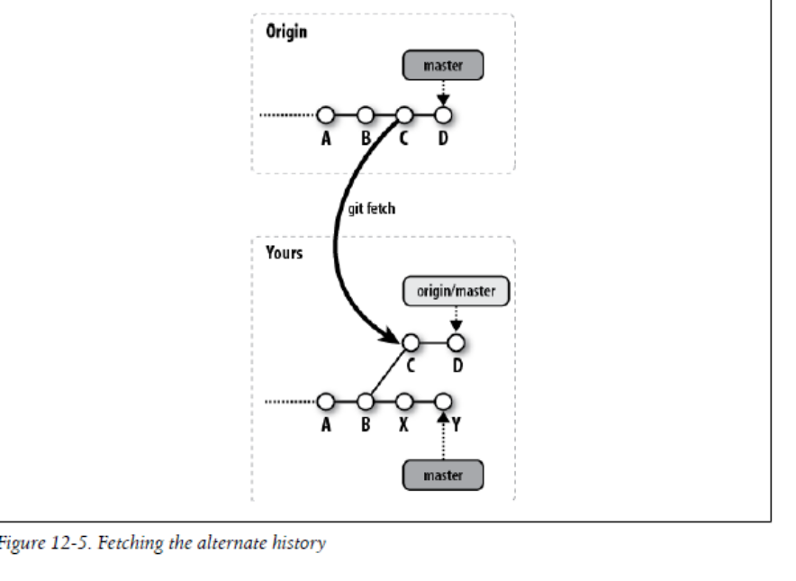
For Git to perform a merge between two alternate histories, both must be present within
one repository on two different branches.

You can carry out the operation through a direct git fetch command or as part of a git pull
command; it doesn’t matter which. In either case, the fetch brings the remote’s commits,
here C and D, into your repository.

Now that both histories are present in one repository, all that is needed to unify them
is a merge of the origin/master branch into the master branch

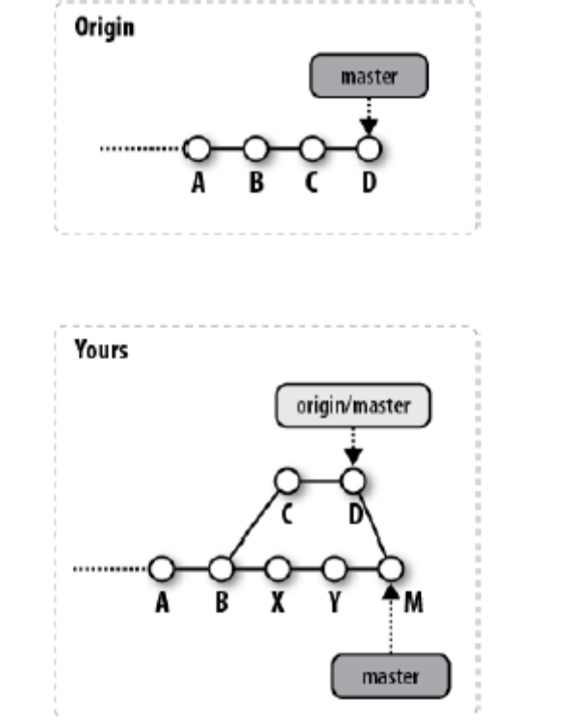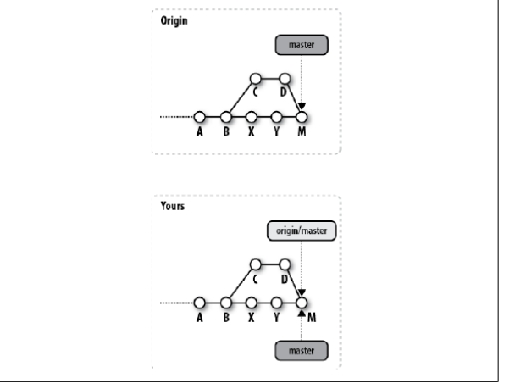
Figure 12-6 shows the commit graph in your repository after the merge has successfully
assimilated the two histories from commit D and Y into a new merge commit, M. The ref
for origin/master remains pointing at D because it hasn’t changed, but master is updated
to the merge commit, M, to indicate that the merge was into the master branch; this is
where the new commit was made.

You may choose to resolve the merge normally, as described in Chapter 9, or you may choose to abort the merge and reset your master branch to its prior ORIG_HEAD state using the command git reset --hard ORIG_HEAD. Doing so in this example would move master to the prior HEAD value, Y, and change your working directory to match. It would also leave origin/master at commit D.

Remote Configuration
Git provides three mechanisms for setting up and maintaining information about remotes: the git remote command, the git config command, and editing the .git/config file directly. All three mechanisms ultimately result in configuration information being recorded in the .git/config file.

Using git remote
The git remote command is a more specialized interface, specific to remotes, that manipulates the configuration file data and remote refs. It has several subcommands with fairly intuitive names

You used git remote add origin to add a new remote named origin to the newly created parent repository in the depot, and you ran the git remote show origin command to extract all the information about the remote origin. Finally, you used the git remote update command to fetch all the updates available in the remote repository into your local repository.

The command git remote rm removes the given remote and all of its associated remotetracking branches from your local repository. To remove just one remote-tracking branch from your local repository, use a command like this:

$ git branch -r -d origin/dev

The remote repository may have branches deleted from it by the actions of other developers, even though your copies of those branches may linger in your repository. The git remote prune command may be used to remove the names of those stale (with respect to the actual remote repository) remote-tracking branches from your localrepository.

To keep even more in sync with an upstream remote, use the command git remote update --prune remote to first get updates from the remote and then prune stale tracking branches all in one step.

To rename a remote and all of its refs, use git remote rename old new. After this command:
$ git remote rename jon jdl
any ref like jon/bugfixes will be renamed as jdl/bugfixes.

In addition to manipulations of the remote name and its refs, you can also update or change the URL of the remote:
$ git remote set-url origin git://repos.example.com/stuff.git

Using git config

The git config command can be used to manipulate the entries in your configuration file directly. This includes several config variables for remotes.

For example, to add a new remote named publish with a push refspec for all the
branches you would like to publish, you might do something like this:
$ git config remote.publish.url 'ssh://git.example.org/pub/repo.git'
$ git config remote.publish.push '+refs/heads/*:refs/heads/*'

Each of the preceding commands adds a line to the .git/config file. As a result, your .git/config contains, in part, the following remote definition:
[remote "publish"]
url = ssh://git.example.org/pub/repo.git
push = +refs/heads/*:refs/heads/*

Use the -l (lowercase L) option à la git config -l to list the contents of the configuration file with complete variable names

Using Manual Editing
Rather than wrestling with either the git remote or git config commands, directly editing the file with your favorite text editor may be easier or faster in some situations.

Working with Tracking Branches
Creating Tracking Branches

Git makes it very easy to create a local- and remote-tracking branch pair using a consistent ref name for them. A simple check out request using the name of a remote-tracking branch causes a new local-tracking branch to be created and associated with the remote-tracking branch. However, Git does this only if your branch name matches just one remote branch name from all of the repository remotes. And by the phrase “branch name matches,” Git means the full branch name after the name of the
remote in a refspec.

$ git branch -a | grep split-blob
remotes/origin/jc/split-blob
$ git branch
* master
$ git checkout jc/split-blob
Branch jc/split-blob set up to track remote branch jc/split-blob from origin.
Switched to a new branch 'jc/split-blob'
$ git branch
* jc/split-blob
Master

Notice that we had to use the full branch name jc/split-blob and not simply splitblob.

In the case when the branch name is ambiguous, you can directly establish and set up the branch yourself.

$ git branch -a | egrep 'maint$'
remotes/korg/maint
remotes/origin/maint
$ git checkout maint
error: pathspec 'maint' did not match any file(s) known to git.
# Just select one of the maint branches.
$ git checkout --track korg/maint
Branch maint set up to track remote branch maint from korg.
Switched to a new branch 'maint'

If for some reason you wish to use a different name for your local-tracking branch, use the -b option.
$ git checkout -b mypu --track korg/pu
Branch mypu set up to track remote branch pu from korg.
Switched to a new branch 'mypu'

Under the hood, Git automatically adds a branch entry to the .git/config to indicate that the remote-tracking branch should be merged into your new local-tracking branch. The collected changes from the previous series of commands yields the following config file:
$ cat .git/config

a detached HEAD is essentially an anonymous branch name.

If you don’t want to check out a local-tracking branch when you create it, you can instead use git branch --track local-branch remote-branch to create the local tracking branch and record the local- and remote-branch association in the .git/config file for you:
$ git branch --track dev origin/dev

And, if you already have a topic branch that you decide should be associated with an upstream repository’s remote-tracking branch, you can establish the relationship using the --upstream option. Typically, this is done after adding a new remote, like this:

$ git remote add upstreamrepo git://git.example.org/upstreamrepo.git
# Branch mydev already existed.
# Leave it alone, but associated it with upstreamrepo/dev.
$ git branch --set-upstream mydev upstreamrepo/dev

Ahead and Behind

To see which commits you have in master that are not in origin/master, use a command like this:
$ git log origin/master..master

you probably want to use the symmetric difference to see the changes:
$ git log origin/master...master

Adding and Deleting Remote Branches

In Chapter 7, you learned how to add new branches to and delete existing ones from your repository using the git branch command. But git branch operates only on a local repository.

To perform similar branch add and delete operations on a remote repository, you need to specify different forms of refspecs in a git push command. Recall that the syntax of a refspec is:
[+]source:destination

Pushes that use a refspec with just a source ref (i.e., with no destination ref) create a new branch in the remote repository
$ git checkout -b foo
$ git push origin foo

push that names only a source is just a shorthand for using the same name for both the source and destination ref name. A push that names both a source and a destination ref that are different can be used to create a new destination named branch or extend an existing destination remote branch with the content from the local source branch
That is, git push origin mystuff:dev will push the local branch mystuff to the upstream repository and either create or extend a branch named dev. Thus, due to a series of default behaviors, the following commands have the same effect:
$ git push upstream new_dev
$ git push upstream new_dev:new_dev
$ git push upstream new_dev:refs/heads/new_dev

Pushes that use a refspec with just a destination ref (i.e., no source ref) cause the destination ref to be deleted from the remote repository. To denote the ref as the destination, the colon separator must be specified:

$ git push origin :foo

If that :branch form causes you heartache, you can use a syntactically equivalent form:
$ git push origin --delete foo

So what about renaming a remote branch? Unfortunately, there is not a simple solution.
The short answer is create a new upstream branch with the new name and then delete
the old branch. That’s easy enough to do using the git push commands as shown
previously.
# Create new name at exiting old commit
$ git branch new origin/old
$ git push origin new
# Remove the old name
$ git push origin :old

But that’s the easy and obvious part. Now what are the distributed implications? Do you know who has a clone of the upstream repository that was just modified out from underneath them? If you do, they could all just fetch and remote prune to get their repositories updated. But if you don’t, then all those other clones will suddenly have dangling tracking branches. And there’s no real way to get them renamed in a distributed way.
Bottom line here: this is just a variant on the “Be careful how you rewrite history” theme.

Bare Repositories and git push

As a consequence of the peer-to-peer semantics of Git repositories, all repositories are of equal stature. You can push to and fetch from development and bare repositories equally, because there is no fundamental implementation distinction between them. This symmetric design is critically important to Git, but it also leads to some unexpected behavior if you try to treat bare and development repositories as exact equals

Recall that the git push command does not check out files in the receiving repository. It simply transfers objects from the source repository to the receiving repository and then updates the corresponding refs on the receiving end.

In a bare repository, this behavior is all that can be expected, because there is no working directory that might be updated by checked out files. That’s good. However, in a development repository that is the recipient of a push operation, it can later cause confusion to anyone using the development repository.

The push operation can update the repository state, including the HEAD commit. That is, even though the developer at the remote end has done nothing, the branch refs and HEAD might change, becoming out of sync with the checked out files and index.

A developer who is actively working in a repository into which an asynchronous push happens will not see the push. But a subsequent commit by that developer will occur on an unexpected HEAD, creating an odd history. A forced push will lose pushed commits from the other developer.

As a result, you are encouraged to push only into a bare repository. This is not a hardand- fast rule, but it’s a good guide to the average developer and is considered a best practice. There are a few instances and use cases where you might want to push into a development repository, but you should fully understand its implications. When you do want to push into a development repository, you may want to follow one of two basic approaches.

CHAPTER 16 Combining Projects

If you do decide to handle submodules by just importing them directly, there are two ways to proceed: by copying the files manually or by importing the history.

Importing Subprojects by Copying

The most obvious way to import another project’s files into your project is by simply copying them. In fact, if the other project isn’t stored in a Git repository, this is your only option.

The steps for doing this are exactly as you might expect: delete any files already in that
directory, create the set of files you want (e.g., by extracting a tarball or ZIP file containing
the library you want to import), and then git add them. For example

$ cd myproject.git
$ rm -rf mylib
$ git rm mylib
$ tar -xzf /tmp/mylib-1.0.5.tar.gz
$ mv mylib-1.0.5 mylib
$ git add mylib
$ git commit

Importing a new version requires you to rerun the full command sequence removing and adding files every time; you can’t just git pull.
Importing Subprojects with git pull -s subtree

Another way to import a subproject into yours is by merging the entire history from that subproject. Of course, it works only if the subproject’s history is already stored in Git.

Gitlinks
A gitlink is a link from a tree object to a commit object.

Recall from Chapter 4 that each commit object points to a tree object and that each tree object points to a set of blobs and trees, which correspond (respectively) to files and subdirectories. A commit’s tree object uniquely identifies the exact set of files, filenames, and permissions attached to that commit. Also recall from “Commit Graphs” on page 74 of Chapter 6, that the commits themselves are connected to each other in a DAG. Each commit object points to zero or more parent commits, and together they describe the history of your project.

But we haven’t yet seen a tree object pointing to a commit object. The gitlink is Git’s mechanism to indicate a direct reference to another Git repository.

The resulting tree looks like this:
$ git ls-tree HEAD
160000 commit ea02eef096d4bfcbb83e76cfab0fcb42dbcad35e git
100644 blob ce013625030ba8dba906f756967f9e9ca394464a hello.txt
The git subdirectory is of type commit and has mode 160000. That makes it a gitlink.

Git usually treats gitlinks as simple pointer values or references to other repositories. Most Git operations, such as clone, do not dereference the gitlinks and then act on the submodule repository.

If you clone your superproject repository, the subproject repository directories will be empty.

In the following example, the git subproject directory remains empty after the clone command:

Gitlinks have the important feature that they link to objects that are allowed to be missing from your repository. After all, they’re supposed to be part of some other repository.

It is exactly because the gitlinks are allowed to be missing that this technique even achieves one of the original goals: partial checkouts. You don’t have to check out every subproject; you can check out just the ones you need.

So now you know how to create a gitlink and that it’s allowed to be missing. But missing objects aren’t very useful by themselves. How do you get them back? That’s what the git submodule command is for.

The git submodule command needs to know one important bit of information before it can do anything: where can it find the repository for your submodule? It retrieves that information from a file called .gitmodules, which looks like this:
[submodule "git"]
path = git
url = /home/bob/git.git

Using the file is a two-step process:
- First,Create the .gitmodules file with git submodule add

The git submodule add command will add an entry to the .gitmodules and populate a new Git repository with a clone of the added repository

- Next, run git submodule init to copy the settings from the .gitmodules file into your .git/config file:
$ git submodule init
$ cat .git/config

[submodule "git"]
url = /home/bob/git.git
The git submodule init command added only the last two lines.

The reason for this step is that you can reconfigure your local submodules to point at a different repository from the one in the official .gitmodules. If you make a clone of someone’s project that uses submodules, you might want to keep your own copy of the submodules and point your local clone at that. In that case, you wouldn’t want to change the module’s official location in .gitmodules, but you would want git submodule to look at your preferred location. So git submodule init copies any missing submodule information from .gitmodules into .git/config, where you can safely edit it. Just find the [submodule] section referring to the submodule you’re changing,and edit the URL.

Finally, run git submodule update to actually update the files, or if needed, clone the initial subproject repository:

Here git submodule update goes to the repository pointed to in your .git/config, fetches the commit ID found in git ls-tree HEAD -- git, and checks out that revision in the directory specified in .git/config.

There are a few other things you need to know:
• When you switch branches or git pull someone else’s branch, you always need to run git submodule update to obtain a matching set of submodules. This isn’t automatic because it could cause you to lose work in the submodule by mistake.
• If you switch to another branch and don’t issue git submodule update, Git will think you have deliberately changed your submodule directory to point at a new commit (when really it was the old commit you were using before). If you then git commit -a, you will accidentally change the gitlink. Be careful!
• You can update an existing gitlink by simply checking out the right version of a submodule, executing git add on the submodule directory, and then running git commit. You don’t use the git submodule command for that.
• If you have updated and committed a gitlink on your branch and if you git pull or git merge another branch that updates the same gitlink differently, then Git doesn’t know how to represent this as a conflict and will just pick one or the other. You must remember to resolve conflicted gitlinks by yourself.

CHAPTER 17 Submodule Best Practices
Submodule Commands

Although the dedicated chapter on submodules provides an exhaustive list of commands, a quick recap of the basic submodule actions is helpful:

git submodule add address localdirectoryname
Register a new submodule for this superproject and, optionally, express it in the specified folder name (can be a subfolder path relative to the root of the project).

git submodule status
Summary of the commit ref and dirtiness state of all submodules at this project level.

git submodule init
Use the .gitmodules long-term storage of submodule information to update the .git/config file used during developer repository actions.

git submodule update
Fetch the submodule contents using the address from .git/config and check out the superproject’s submodule-recorded ref in a detached HEAD state.

git submodule summary
Display a patch of the changes of each submodule’s current state as compared to its committed state.

git submodule foreach command
Scripts a shell command to be run on each submodule and provides variables for $path, $sha1, and other useful identifiers.

Examining the Hashes of Submodule Commits

For developers wanting to examine their project one level deeper than t hey will use it on a daily basis, the recording of a submodule commit ref is a fascinatingly simple thing to observe. The ref of the submodule’s commit is stored in the tree just as the ref of a subdirectory or blob would be, but with an entry type of commit rather than tree or blob.

$ git ls-tree HEAD

CHAPTER 18 Using Git with Subversion Repositories

To begin, let’s make a shallow clone of a single SVN branch. Specifically, let’s work with the source code of SVN itself (which is guaranteed to be managed with SVN for as long as this book is in print) and a particular set of revisions, 33005 through 33142, from the 1.5.x branch of SVN.

The first step is to clone the SVN repository:

$ git svn clone -r33005:33142 \ http://svn.collab.net/repos/svn/branches/1.5.x/ svn.git

CHAPTER 19 Advanced Manipulations
Using git filter-branch
The command git filter-branch is a generic branch processing command that allows you to arbitrarily rewrite the commits of a branch using custom commands that operate on different objects within the repository

Using git filter-branch to expunge a file
A common use for git filter-branch is to completely remove a file from the entire history of a repository. Remember, Git maintains the complete history of every file within the repository. Thus, simply deleting a file with git rm will not remove it from older history. One can always go back to earlier commits and retrieve the file.
$ git filter-branch --tree-filter 'rm -f 1984' master

For the terminally curious, the corresponding command using index-filter would be something like this:
$ git filter-branch --index-filter 'git rm --cached --ignore-unmatch 1984' master

Using filter-branch to edit a commit message

$ git filter-branch --msg-filter 'sed -e "/1984/d" -e "s/few classics/classic/" ' master

At its core, the git filter-branch command is designed to operate on just one branch or ref. However, it can operate on many branches or refs.
In many cases, you want to have it operate on all branches so as to obtain a repositorywide coverage. In these cases, you will need the -- --all tacked onto the end of the command.

How I Learned to Love git rev-list
Date-Based Checkout

Think of git rev-list and its myriad options as a commit database front-end query tool for your repository.

$ git rev-list -n 1 --before="Jan 1, 2012 00:00:00" master
SHA1. The -n 1 option limits the output from the command to just one commit ID.

Retrieve Old Version of a File:

There are three slightly different approaches you can use to get that version of a file. The first form directly checks out the named version and overwrites the existing version in your working directory.

$ git checkout ecee9d9 date.c

In two other very similar commands, Git accepts the form commit:path to name the desired file (i.e., path) as it existed at the time the commit happened, and writes the specified version of the file to be written to stdout. What you do with that output is up to you, though. You could pipe the output to other commands or create files:

$ git show ecee9d9:date.c > date.c-oldest

Or:
$ git cat-file -p 89967:date.c > date.c-first-change

The difference between these two forms is a bit esoteric. The former filters the output file through any applicable text conversion filters, whereas the latter is a more basic, plumbing command and does not

If you want the raw data, use the cat -p form. If you want the transformed version as it would be when checked out or added to the repository, use the show form.

These are exactly the same mechanisms you would use to obtain versions of a file as it
appears in another branch:

$ git checkout dev date.c
$ git show dev:date.c > date.c-dev

Or even earlier on the same branch:

$ git checkout HEAD~2:date.c

Interactive Hunk Staging

Staging hunks interactively is as easy as adding the -p option to the git add command!
$ git add -p file.c
Interactive hunk staging looks pretty easy, and it is. But we should probably still have a mental model in mind of what Git is doing with our patches. Remember way back in Chapter 5, I explained how Git maintains the index as a staging area that accumulates your changes prior to committing them

Recovering a Lost Commit

For whatever reason, sometimes the reflog cannot help recover a lost commit.
Although not foolproof, Git provides the command git fsck to help locate lost data. The word “fsck” is an old abbreviation for “file system check.” Although this command does not check your filesystem,

Understanding how git fsck works is predicated on a good understanding of Git’s
data structures as described in Chapter 4. Normally, every object in the Git repository,
whether it is a blob, tree, commit, or tag, is connected to another object and anchored
to a branch name, tag name, or some other symbolic ref such as a reflog name

However, various commands and manipulations can leave objects in the object store
that are not linked into the complete data structure somehow. These objects are called
“unreachable” or “dangling.”

$ git reset --hard HEAD^
HEAD is now at f85b097 Add some foo
$ git fsck
Checking object directories: 100% (256/256), done

But wait! git fsck doesn’t report any dangling object. It doesn’t seem to be lost after
all. This is exactly what the reflog is designed to do: prevent you from accidentally
losing commits. (See “The Reflog” on page 189.)
So let’s try again after brutally eliminating the reflog:
# Not recommended; this is for purposes of exposition only!
$ rm -rf .git/logs
$ git fsck
Checking object directories: 100% (256/256), done.
dangling commit 11e0dc9c11d8f650711b48c4a5707edf5c8a02fe

You can use the git fsck --no-reflog command to find dangling objects as if the reflog were not available to reference commits. That is, objects that are only reachable from the reflog will be considered unreachable

Sometimes, though, git fsck will find blobs that are unreferenced. Remember, every
time you git add a file to the index, its blob is added to the object store. If you subsequently
change that content and re-add it, no commit will have captured the intermediate
blob that was added to the object store. Thus, it will be unreferenced.

$ echo baz >> file
$ git add file
$ git fsck
Checking object directories: 100% (256/256), done.
dangling commit 11e0dc9c11d8f650711b48c4a5707edf5c8a02fe
$ echo quux >> file
$ git add file
$ git fsck
Checking object directories: 100% (256/256), done.
dangling blob 0c071e1d07528f124e31f1b6c71348ec13f21a7a
dangling commit 11e0dc9c11d8f650711b48c4a5707edf5c8a02fe

The reason the first git fsck didn’t show a dangling blob was because that blob was
still referenced directly by the index. Only after the content associated with the pathname
file was changed again and re-added did that blob become dangling

If you find you have a very cluttered git fsck report consisting entirely of unnecessary
blobs and commits and want to clean it up, consider running garbage collection as
described in “Garbage Collection” on page 368.

Reconnecting a Lost Commit

The question remains, once you know it, how do you reconnect it or otherwise
incorporate it into your project?

By definition, blobs are nameless file content. All you really have to do to reestablish a
blob is place that content into a file and git add it again. As I showed in the previous
section, git show can be used on the blob SHA1 to obtain the full object content. Just
redirect that to your desired file:
$ git show 0c071e1d > file2

Maybe even an entire branch was accidentally lost! Consequently, a usual practice would reintroduce a lost commit as a branch.

Here, the previously lost commit that introduced the bar content, 11e0dc9c, is re-introduced on the new branch called recovered:
$ git branch recovered 11e0dc9c

CHAPTER 20 Tips, Tricks, and Techniques

With a plethora of commands and options, Git provides a rich resource for performing
varied and powerful changes to a repository. Sometimes, though, the actual means for
accomplishing some particular task are a bit elusive. Sometimes, the purpose of a
particular command and option isn’t really clear or becomes lost in a technical description.
This chapter provides a collection of various tips, tricks, and techniques that highlight
Git’s ability to do interesting transformations

Interactive Rebase with a Dirty Working Directory
Frequently, when developing a multicommit change sequence on a local branch, I
realize that I need to make an additional modification to some commit I’ve already
made earlier in the sequence. Rather than scribbling a note about it on the side and
coming back to it later, I will immediately edit and introduce that change directly into
a new commit with a reminder note in the commit log entry that it should be squashed
into a previous commit.

$ git show-branch --more=10
[master] Tinker bar
[master^] Squash into 'More foo and bar'
[master~2] Modify bar
[master~3] More foo and bar
[master~4] Initial foo and bar.
$ git rebase -i master~4
Cannot rebase: You have unstaged changes.
Please commit or stash them.

Remove Left-Over Editor Files

Because the git filter-branch command really drives a shell operation, either the --index-filter command or the --tree-filter command can use normal shell wild card matching in its command. That can be handy when you accidentally add, say, temporary editor files on first creating your repository.

$ git filter-branch --tree-filter 'rm -f *~' -- --all

That command will remove all files matching the *~ pattern from -- --all refs in one command.

Garbage Collection
The problem, however, is that over a long period, manipulating the repository can be messy and leave many unreferenced objects in your object store

such unreferenced objects are cleaned up by an algorithm called “garbage collection.” It is the job of the git gc command to perform periodic garbage collection and keep your repository object stores neat and tidy.

Quick Overview of Changes

If you need to keep a repository up to date by continually fetching from an upstream
source, you may find yourself frequently asking a question similar to, “So, what
changed in the last week?”
The answer to your wonderment might be the git whatchanged command

$ git whatchanged --since="three days ago" --oneline

That’s dense. But we did ask for --oneline! So the commit log has been summarized in single lines like this:

And each of those are followed by the list of files that changed with each commit:

:100755 100755 f8dd536... cf8e1ef... M t/perf/p0000-perf-lib-sanity.sh
:100644 100644 bcc0131... 5580c22... M t/perf/perf-lib.sh

That’s file mode bits, before and after the commit, the SHA1s of each blob before and after the commit, a status letter (M here means modified content or mode bits), and finally the path of the blob that changed.

Although the previous example defaulted the branch reference to master, you could
pick anything of interest, or explicitly request the set of changes that were just fetched:
$ git whatchanged ORIG_HEAD..HEAD
You can also limit the output to the set of changes that affect a named file:
$ cd /usr/src/linux
$ git pull
$ git whatchanged ORIG_HEAD..HEAD --oneline Makefile

Cleaning Up

The git clean command may be used to remove untracked files from your working tree

By default, git clean just removes all files that are not under version control from the current directory and down through your directory structure. Untracked directories are considered slightly more valuable than plain files and are left in place unless you supply the -d option.

Furthermore, for the purposes of this command, Git uses a slightly more conservative
concept of under version control. Specifically, the manual page uses the phrase “files
that are unknown to Git” for a good reason: even files that are mentioned in the .gitignore and .git/info/exclude files are actually known to Git. They represent files that are not version controlled, but Git does know about them. And because those filesare called out in the .gitignore files, they must have some known (to you) behavior that shouldn’t be disturbed by Git. So Git won’t clean out the ignored files unless you explicitly request it with the -x option.

Naturally, the -X option causes the inverse behavior: namely, only files explicitly ignored by Git are removed. So choose the files that are important to you carefully.

If you are skittish, do a --dry-run first.

Using git-grep to Search a Repository
You may recall from “Using Pickaxe” on page 88 that I introduced the pickaxe option (spelled -Sstring) for the git log command,

Another command that can be used to search a repository is git grep. Rather than searching each commit’s changes to a branch, the git grep command searches the content of files within a repository. Because git grep is really a generic Swiss Army knife with a multitude of options, it is more accurate to say that git grep searches for text patterns in tracked blobs (i.e., files) of the work tree, blobs cached in the index, or blobs in specified trees. By default, it just searches the tracked files of the working tree.

Thus, pickaxe can be used to search a series of commit differences, whereas git grep can be used to search the repository tree at a specific point in that history.

$ git grep -i loeliger
$ git grep -l git-grep

A few things to note here: git-grep supports many of the normal command line options to the traditional grep tool, such as -i for case insensitive searches, -l for a list of just the matching file names, -w for word matching, etc. Using the -- separator option, you can limit the paths or directories that Git will search. To limit the search to the occurrence within the Documentation/ directory, do something like this:

$ git grep -l git-grep -- Documentation

Using the --untracked option, you can also search for patterns in untracked (but not
ignored) files that have neither been added to the cache nor committed as part of the
repository history. This option may come in handy if you are developing some feature
and have started adding new files but haven’t yet committed them. A default
git grep wouldn’t search there, even though your past experience with the traditional
grep command might lead you to believe that all files in your working directory (and
possibly its subdirectories) would otherwise be searched.

There are several benefits to building the git grep command directly into the Git toolset.
First, speed and simplicity. Git doesn’t have to completely check out a branch in
order to do the search; it can operate directly on the objects from the object store.

Following Files that Moved
If, over the history of a file, it is moved from one place to another within your repository
directory structure, Git will usually only trace back over its history using its current
name.

To see the complete history of the file, even across moves, use the --follow as well. For
example, the following command shows the commit log for a file currently named file, but includes the log for its prior names as well:

$ git log –-follow file

Add the --name-only option to have Git also state the name of that file as it changes:
$ git log –-follow --name-only file

21 Git and Github

Disk backup tools like SparkleShare.

Pushing the Local Contents to GitHub
Once one of the two options has been followed to connect the local repository to the remote repository, the contents of the local repo can be pushed to GitHub. This is done with the git push remote branch command. If the branch has never been published before, the more specific invocation git push -u origin master is appropriate, in which -u tells Git to track the pushed branch, push it to the origin remote, and to push just the master branch

Forks
The next idea that GitHub popularized, so much so that the phrase has spread to other
domains, is personal forks of projects (Figure 21-11). The term forking has commonly
carried a negative connotation. In the coding landscape of yesteryear, forking often
meant an aggressive parting of ways with the primary copy of the project with the intent
of taking the program in a different direction.
GitHub’s idea of forking is a positive one that enables a greater number of contributors
to make a greater number of contributions in a controlled and highly visible way. Forking
is the democratic ability of any potential contributor to get a personal copy of a
project’s code.

